## Design

### Use Case

#### Admin

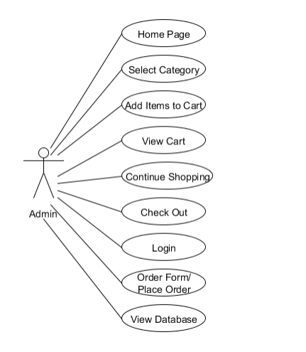

Figure

#### User



Figure

### Activity

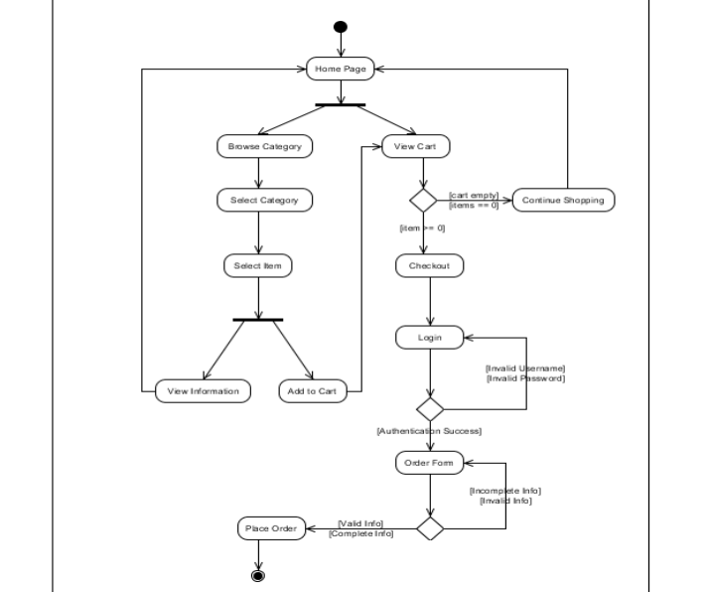

Figure

### Use Case

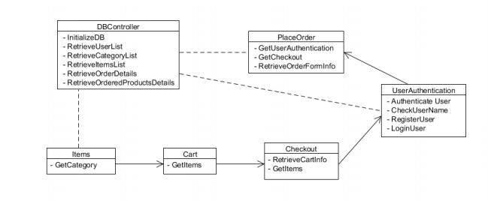

Figure

The Website contain the following pages:

### Single (Code that have been used once )

* **Main Page** – index.php
* **Admin Page** – admin.php
* **Men Page** – men.php
  + **Tops Page** - top.php
    - **Formal Shirt Page** – formal-shirt.php
    - **Casual Shirt Page** – casual-shirt.php
    - **T-Shirt Page** – t-shirt.php
    - **Jacket Page** – jacket.php
    - **Coat Page** – coat.php
  + **Bottom Page** - bottom.php
    - **Jean Page** – jean.php
    - **Sweatpant Page** – sweatpant.php
    - **Trouser Page** – trouser.php
    - **Short Page** – short.php
  + **Accessories Page** – accessories.php
    - **Cap Page** – cap.php
    - **Sunglass Page** – sunglass.php
    - **Wallet Page** – Wallet.php
    - **Watch Page** – watch.php
    - **Belt Page** – belt.php
  + **Footwear Page** – footwear.php
    - **Formal Shoe** – formal-shoe.php
    - **Sneaker Page** - sneaker.php
    - **Sandal Page** – sandal.php
    - **Sock Page** – sock.php
* **Women Page** – women.php
  + **Tops Page** - top.php
    - **Shirt Page** – shirt.php
    - **T-Shirt Page** – t-shirt.php
    - **Jacket Page** – jacket.php
    - **Coat Page** – coat.php
  + **Bottom Page** - bottom.php
    - **Jean Page** – jean.php
    - **Sweatpant Page** – sweatpant.php
    - **Trouser Page** – trouser.php
    - **Skirt Page** – skirt.php
  + **Accessories Page** – accessories.php
    - **Cap Page** – cap.php
    - **Sunglass Page** – sunglass.php
    - **Handbag Page** – Handbag.php
    - **Watch Page** – watch.php
    - **Belt Page** – belt.php
  + **Footwear Page** – footwear.php
    - **High Heel** – high-heel.php
    - **Sneaker Page** - sneaker.php
    - **Sandal Page** – sandal.php
    - **Sock Page** – sock.php
* **About Page –** about.php
* **Cart Page** – cart.php

### Multipage (Codes that have been used in multiple pages)

* **Profile**
  + Used in:
    - ALL
* **Side Cart** – sidecart.php
  + Used in:
    - ALL
* **Header** – header.php
  + Used in:
    - **Admin Page** – admin.php
    - **Main Page** – index.php
* **Footer** – footer.php
  + Used in:
    - **Admin Page** – admin.php
    - **Main Page** – index.php
* **Header** – semi_header.php
  + Used in:
    - **Women Page** – admin.php
    - **Men Page** – index.php
    - **Cart Page** – cart.php
    - **About Page** – about.php
* **Footer** – semi_footer.php
  + Used in:
    - **Women Page** – admin.php
    - **Men Page** – index.php
    - **Cart Page** – cart.php
    - **About Page** – about.php
* **Header** – semi_subheader.php
  + Used in:
    - Men
      * **Top Page** – top.php
      * **Bottom Page** – bottom.php
      * **Accessories –** accessories.php
      * **Footwear –** footwear.php
    - Women
      * **Top Page** – top.php
      * **Bottom Page** – bottom.php
      * **Accessories –** accessories.php
      * **Footwear –** footwear.php
* **Footer** – semi_subfooter.php
  + Used in:
    - Men
      * **Top Page** – top.php
      * **Bottom Page** – bottom.php
      * **Accessories –** accessories.php
      * **Footwear –** footwear.php
    - Women
      * **Top Page** – top.php
      * **Bottom Page** – bottom.php
      * **Accessories –** accessories.php
      * **Footwear –** footwear.php
* **Header** – subheader.php
  + Used in:
* Men
  + Tops
    - **Formal Shirt Page** – formal-shirt.php
    - **Casual Shirt Page** – casual-shirt.php
    - **T-Shirt Page** – t-shirt.php
    - **Jacket Page** – jacket.php
    - **Coat Page** – coat.php
  + Bottom
    - **Jean Page** – jean.php
    - **Sweatpant Page** – sweatpant.php
    - **Trouser Page** – trouser.php
    - **Short Page** – short.php
  + Accessories
    - **Cap Page** – cap.php
    - **Sunglass Page** – sunglass.php
    - **Wallet Page** – wallet.php
    - **Watch Page** – watch.php
    - **Belt Page** – belt.php
  + Footwear
    - **Formal Shoe** – formal-shoe.php
    - **Sneaker Page** - sneaker.php
    - **Sandal Page** – sandal.php
    - **Sock Page** – sock.php
* Women
  + Tops
    - **Shirt Page** – shirt.php
    - **T-Shirt Page** – t-shirt.php
    - **Jacket Page** – jacket.php
    - **Coat Page** – coat.php
  + Bottom
    - **Jean Page** – jean.php
    - **Sweatpant Page** – sweatpant.php
    - **Trouser Page** – trouser.php
    - **Skirt Page** – skirt.php
  + **Accessories** 
    - **Cap Page** – cap.php
    - **Sunglass Page** – sunglass.php
    - **Handbag Page** – handbag.php
    - **Watch Page** – watch.php
    - **Belt Page** – belt.php
  + Footwear
    - **High Heel** – high-heel.php
    - **Sneaker Page** - sneaker.php
    - **Sandal Page** – sandal.php
    - **Sock Page** – sock.php
* **Footer** – subfooter.php
  + Used in:
* Men
  + Tops
    - **Formal Shirt Page** – formal-shirt.php
    - **Casual Shirt Page** – casual-shirt.php
    - **T-Shirt Page** – t-shirt.php
    - **Jacket Page** – jacket.php
    - **Coat Page** – coat.php
  + Bottom
    - **Jean Page** – jean.php
    - **Sweatpant Page** – sweatpant.php
    - **Trouser Page** – trouser.php
    - **Short Page** – short.php
  + Accessories
    - **Cap Page** – cap.php
    - **Sunglass Page** – sunglass.php
    - **Wallet Page** – wallet.php
    - **Watch Page** – watch.php
    - **Belt Page** – belt.php
  + Footwear
    - **Formal Shoe** – formal-shoe.php
    - **Sneaker Page** - sneaker.php
    - **Sandal Page** – sandal.php
    - **Sock Page** – sock.php
* Women
  + Tops
    - **Shirt Page** – shirt.php
    - **T-Shirt Page** – t-shirt.php
    - **Jacket Page** – jacket.php
    - **Coat Page** – coat.php
  + Bottom
    - **Jean Page** – jean.php
    - **Sweatpant Page** – sweatpant.php
    - **Trouser Page** – trouser.php
    - **Skirt Page** – skirt.php
  + Accessories
    - **Cap Page** – cap.php
    - **Sunglass Page** – sunglass.php
    - **Handbag Page** – handbag.php
    - **Watch Page** – watch.php
    - **Belt Page** – belt.php
  + Footwear
    - **High Heel** – high-heel.php
    - **Sneaker Page** - sneaker.php
    - **Sandal Page** – sandal.php
    - **Sock Page** – sock.php

### Header

The header is in all the pages that are made into four version due to the directory of pages in the website. The following version are named as:

* Header
* Subheader
* Semiheader
* Semi_subheader

All the headers contain the function of going to all the pages in the website. It also contain the option to open the side cart so the users can see their order dynamically rather than going back and forth from the cart page to the current page. The header also contains user profile so that the person can log in if they have an account. And if not to be able to register. It is also made so that when the user is logged in accordingly the name and the type of account is shown. And if the account is an admin type then the option for going to the admin page is shown as a dashboard button.

### Code Snippet

In the folder in the name of “header.png”

### Footer

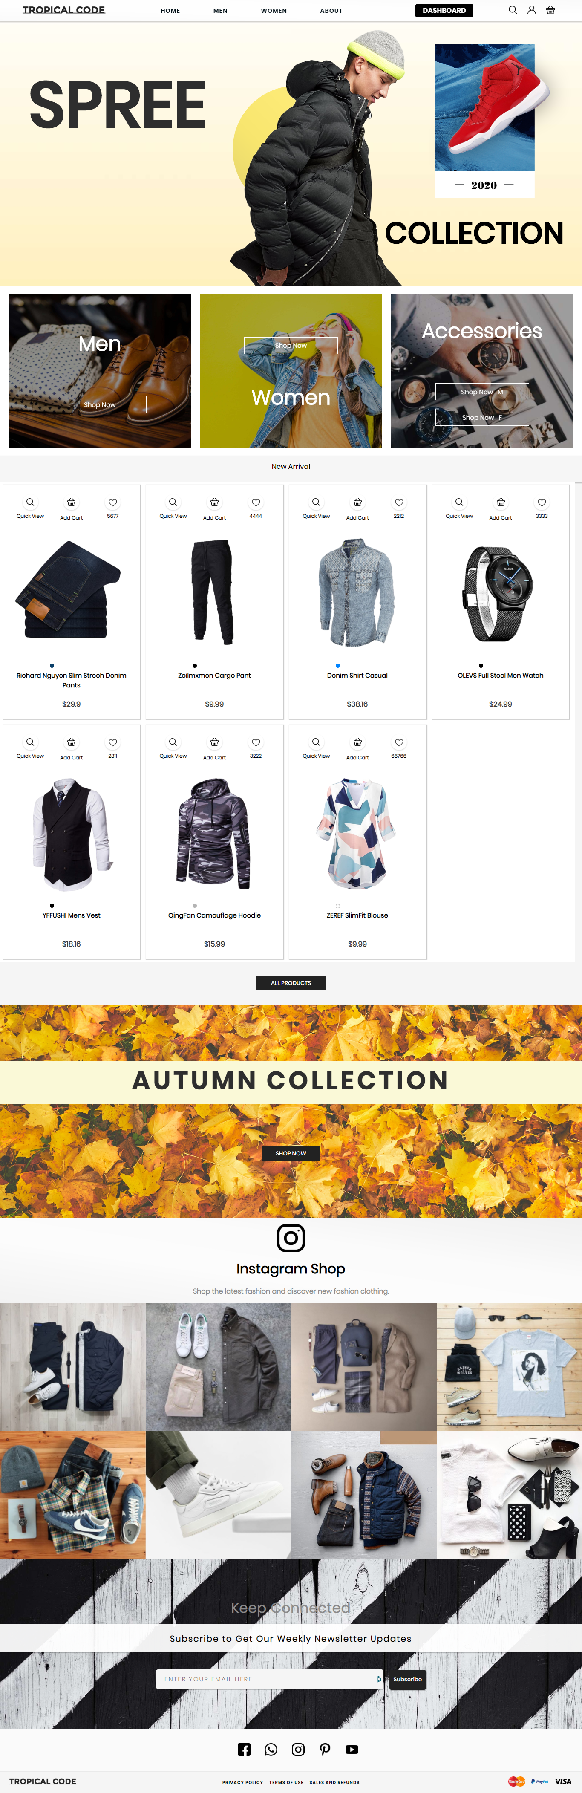

Figure (Format 1, 2020)



Figure (Format 2, 2020)

The footer is in all the pages that are made into four version due to the directory of pages in the website. The following version are named as:

* Footer
* Subfooter
* Semifooter
* Semi_subfooter

The footer contain the social link in representation of their specialized icon that has links to the stores accounts. It also have the policy and conditions so that users if wanted can see about. The footer also have the option for user to subscribe so that any news regarding the store can be informed to them.

### Code Snippet

In the folder in the name of “footer.png”

### Side Cart

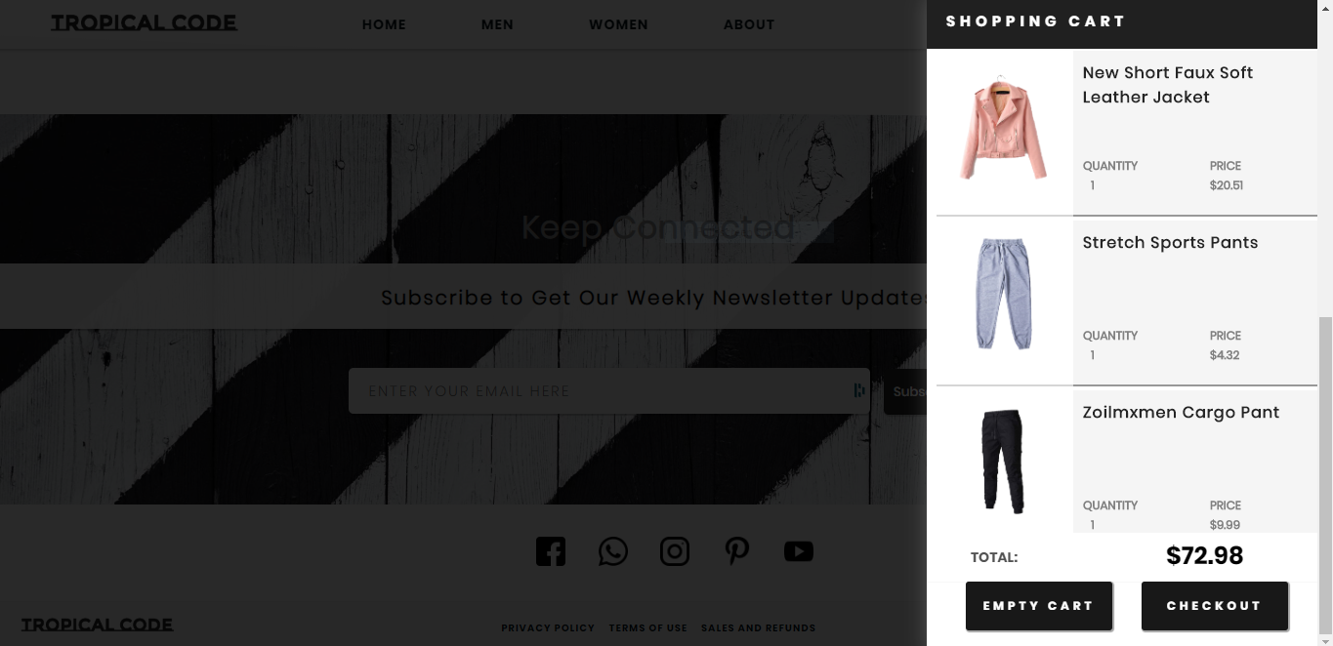

Figure

The side cart is used in all the pages since it must be done that way as a requirement. The side cart is coded as part in all the pages so that when used it can be enabled. The side cart shows all the product that the user has added and gives the total value for them. It also contains two option, the first one is to empty the cart and the second is to go to the cart page so they can finalize their shopping.

### Code Snippet

In the folder in the name of “sidecart.png”

### Profile

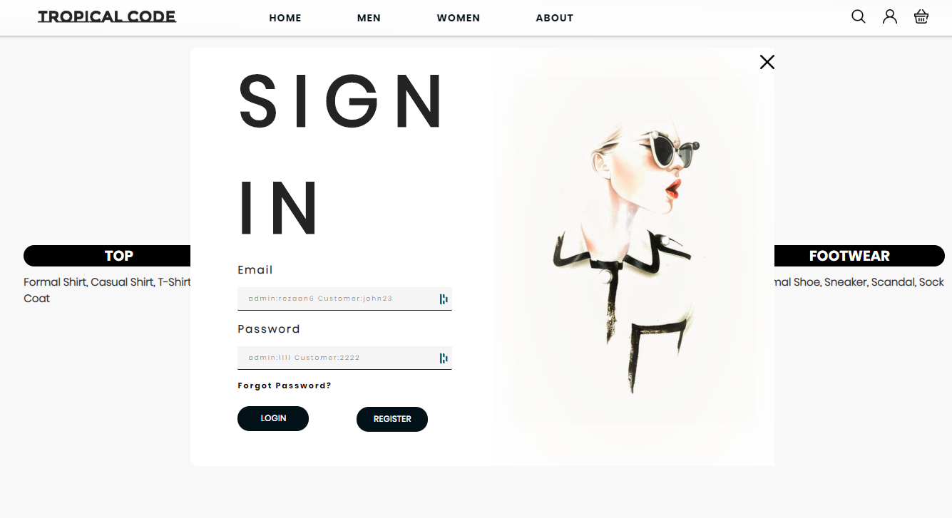

Figure (Sign in format, 2020)

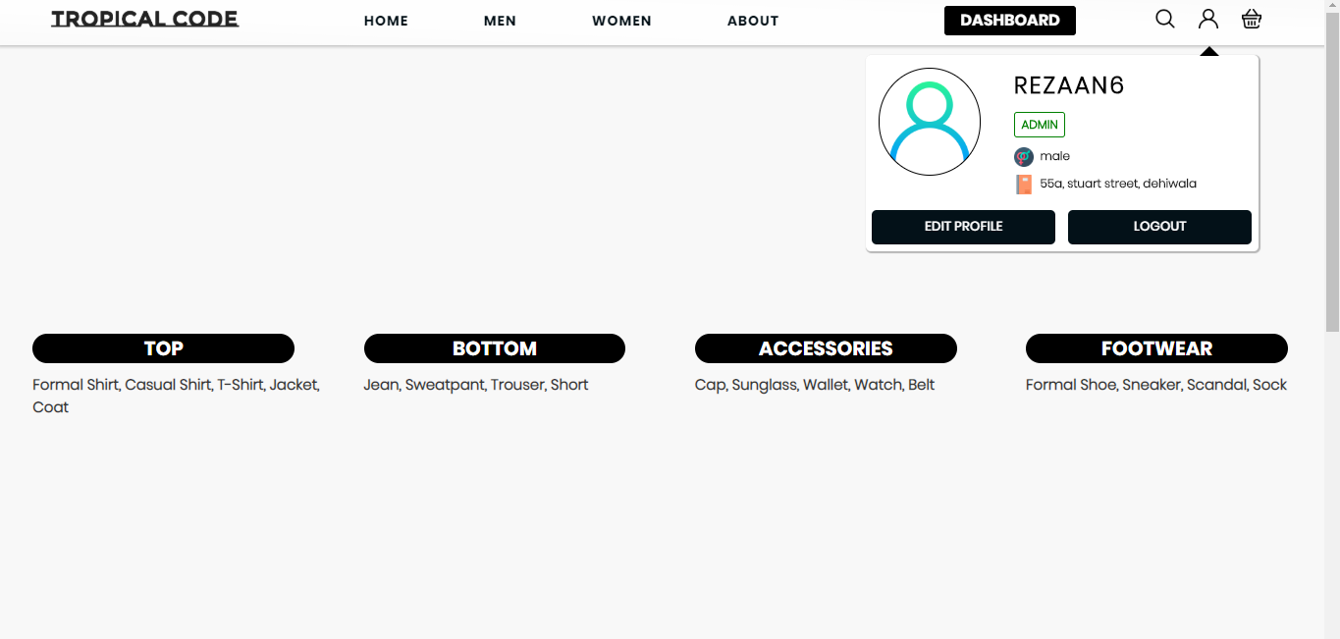

Figure (Admin Profile, 2020)

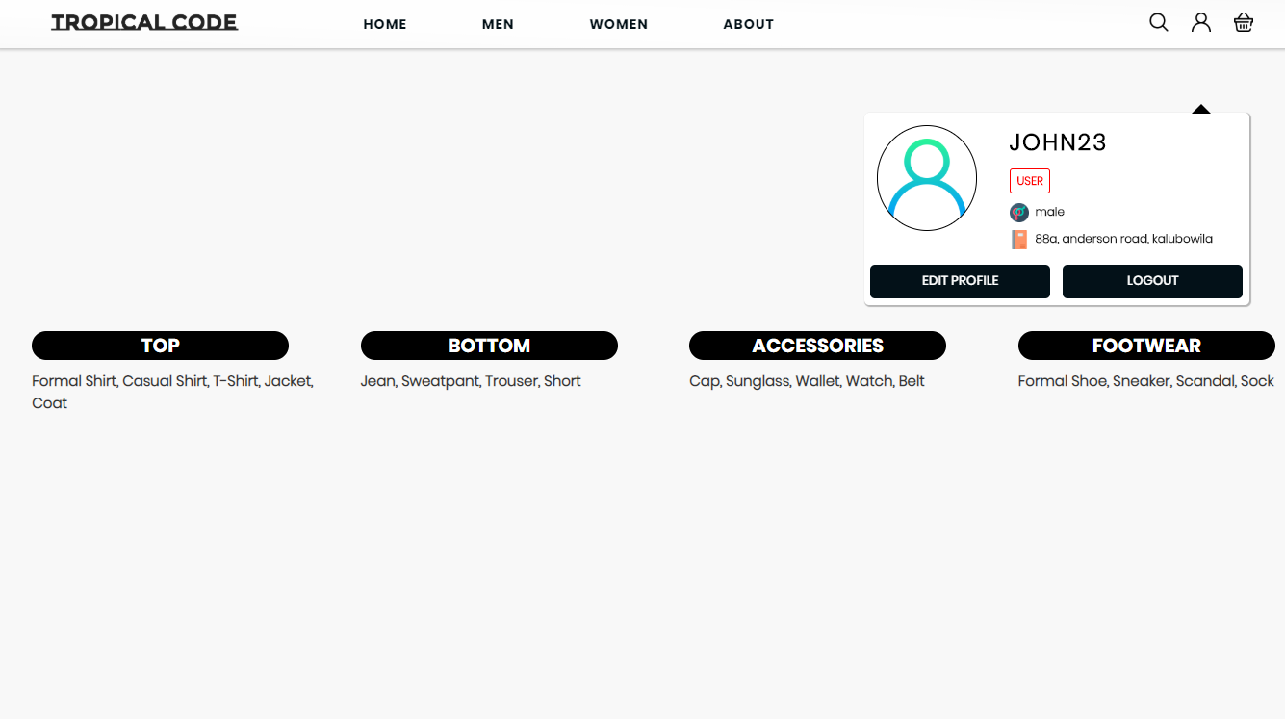

Figure (User Profile, 2020)

The Profile is also like the cart given to all the pages as a code. It has two formats in which it is made. One is where the sign in dial box comes in if the user hasn’t logged in and the other is when the user have logged in whether its an admin or a user, depending on it will show the detail of the profile when clicked as a dropped down option.

### Search

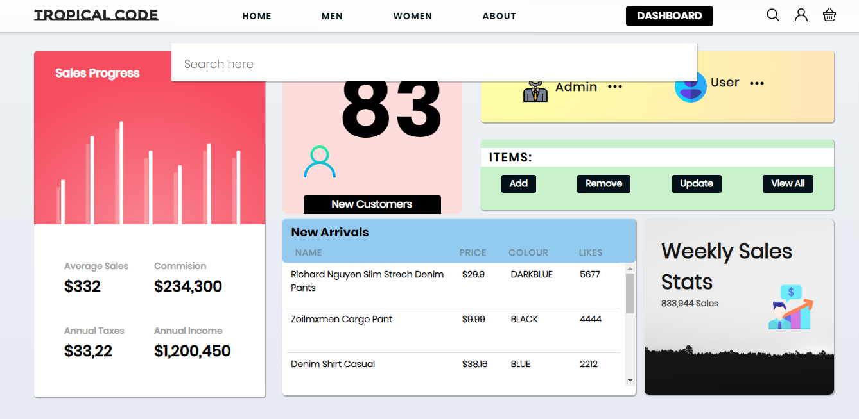

Figure

The search is made so the users can easily get the information they need regarding the store in the website. And it is a function in all the pages as well.

### Main Page

The main page contain section that of which each has its uses. The following section are:

* Header
* Sidecart
* Profile
* Search
* Slide – which has the slideshow that has poster to show any new deals.
* Options – which has three square for clickable link to go to the men, women or accessories page.
* Tab – all the new arrivals product are displayed in it.
* Collection – shows a poster for the current weather collection menu
* Instagram – a tab that showcase all the Instagram Pictures to promote.
* Subscribe – a section for users to subscribe for news about the store.
* Footer

#### Slide



#### Option



#### Tab



#### Collection



#### Instagram



### Code Snippet

In the folder in the name of “index.png”

### Admin Page

The admin page is initialized when the user logs in as an admin and click the dashboard. The admin page is made so the admin could add, remove, update any item or user profile. It also shows the number of sales and the revenue of the store.

The admin contain the following section:

* Header
* Profile
* Search
* Side Cart
* Dashboard – Add, Remove, Update, View all(for the items and the profile)
* Footer

#### Dashboard

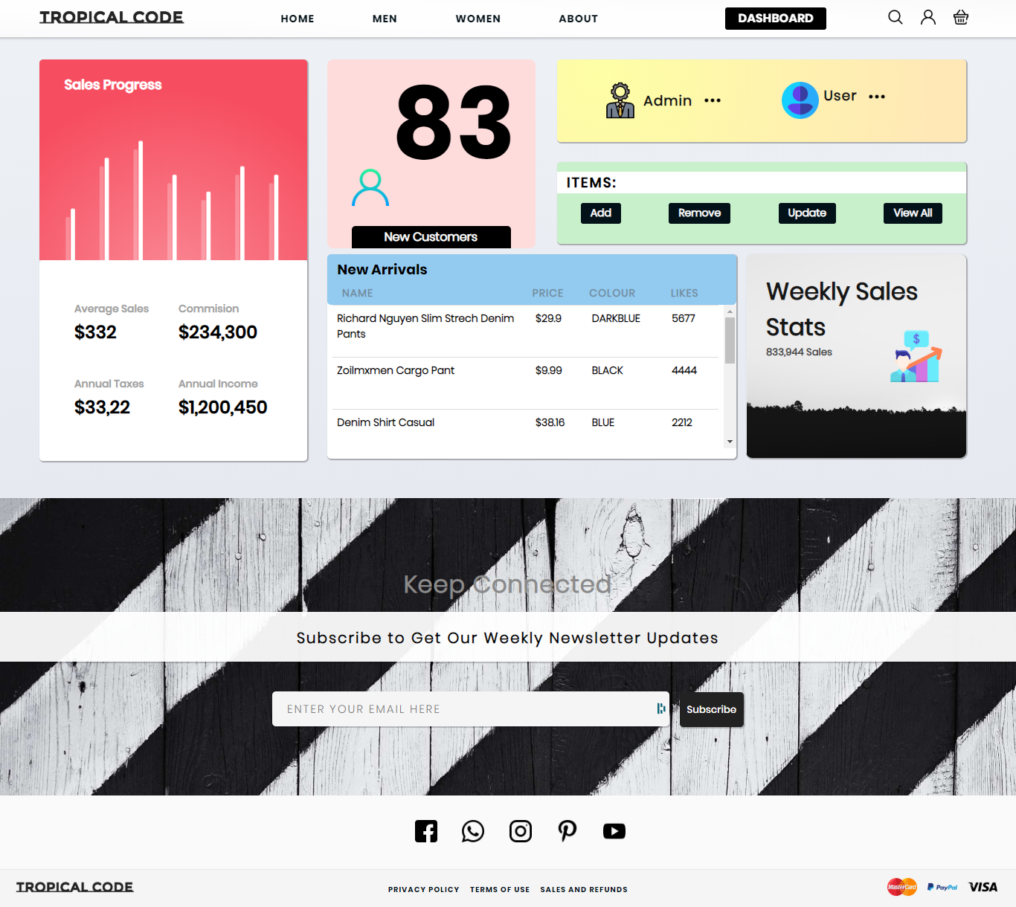

Figure

##### Admin Dropdown

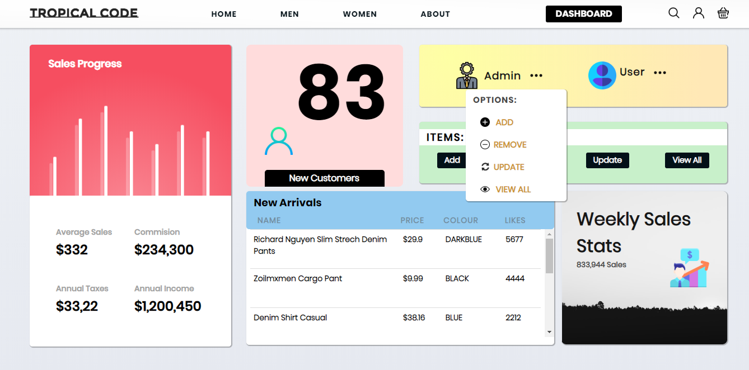

Figure

###### Add Admin

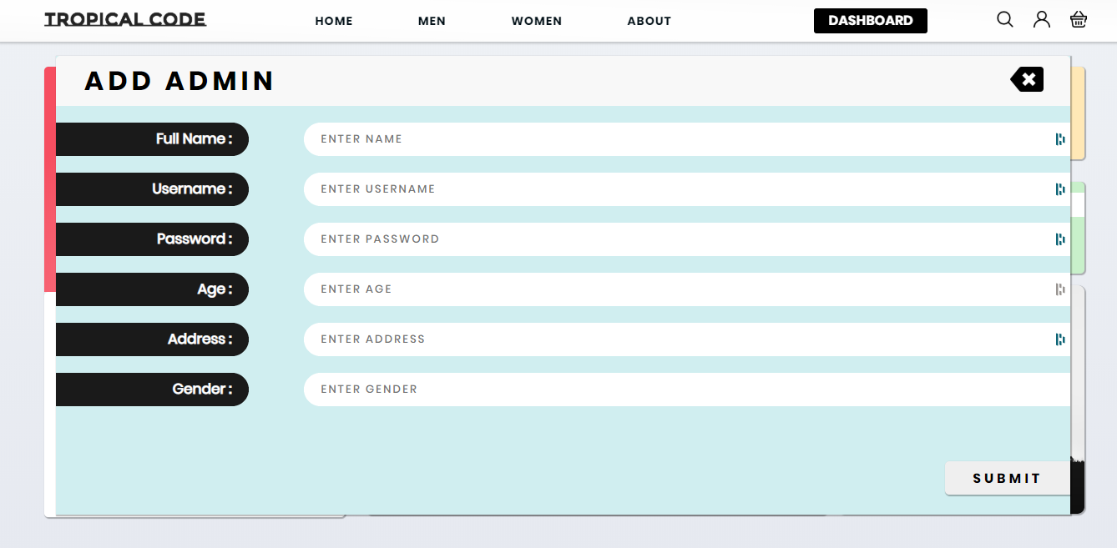

Figure

###### Remove Admin

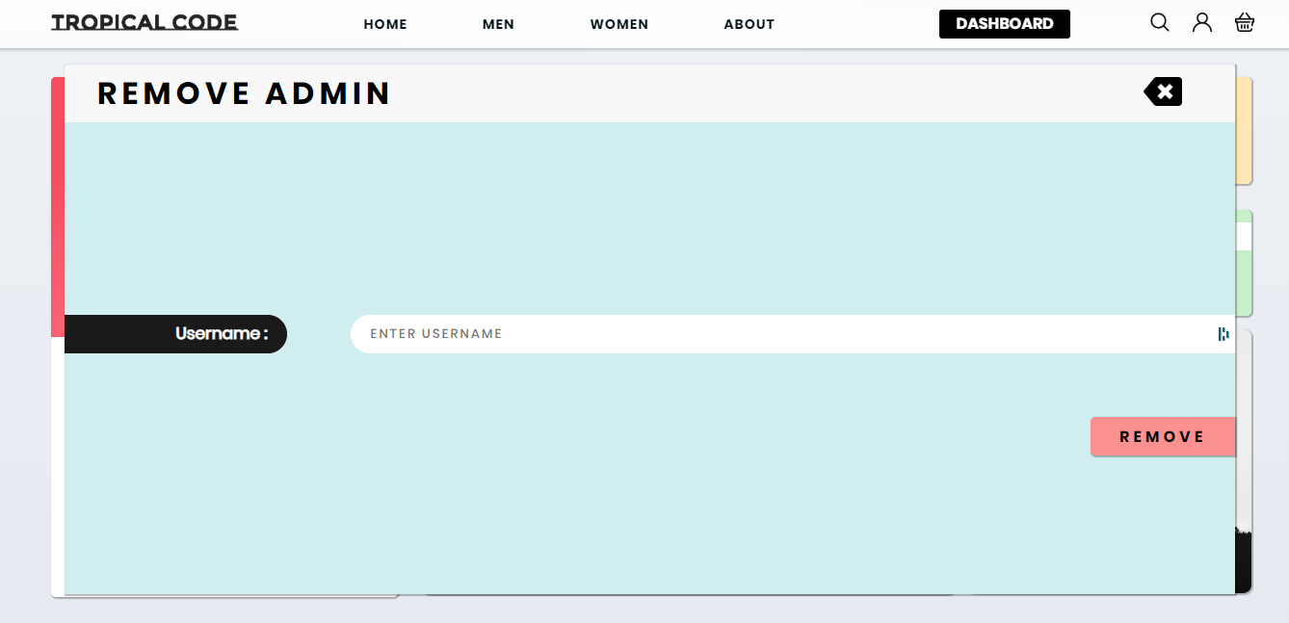

Figure

###### Update Admin

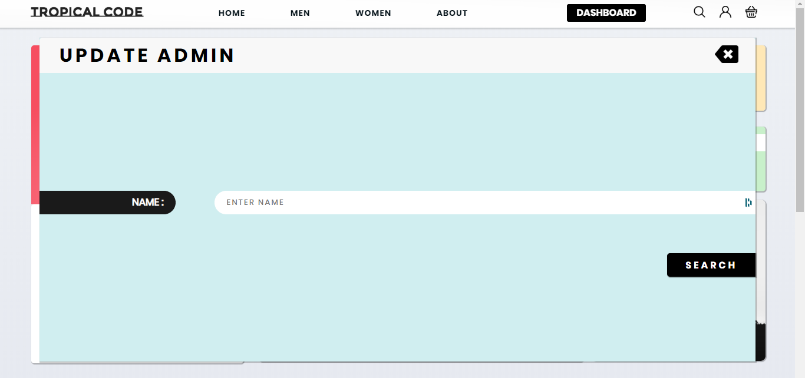

Figure

###### View Admin

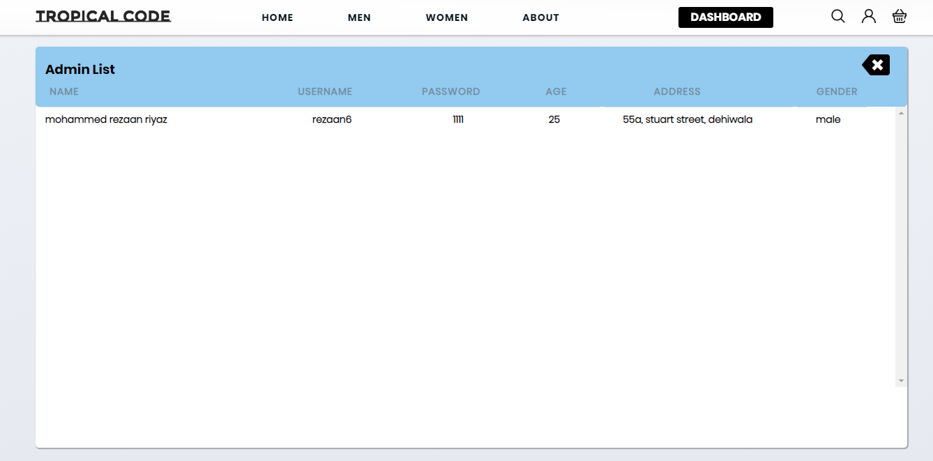

Figure

##### User Dropdown

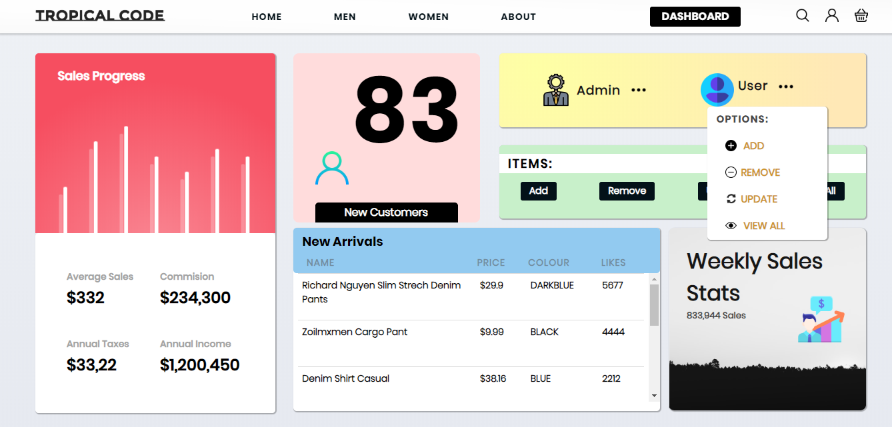

Figure

###### Add User

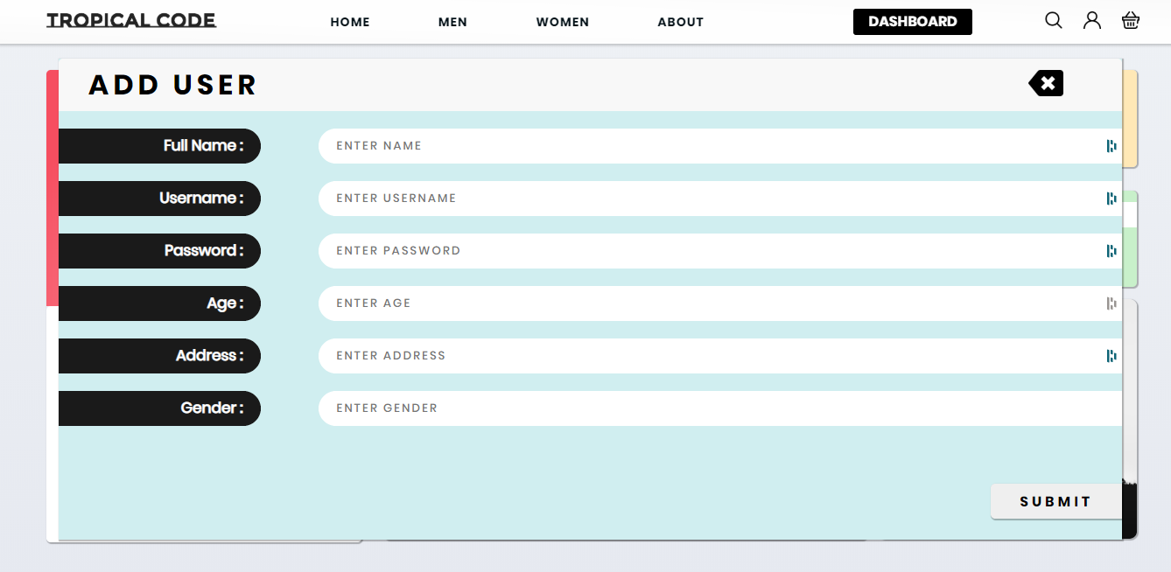

Figure

###### Remove User

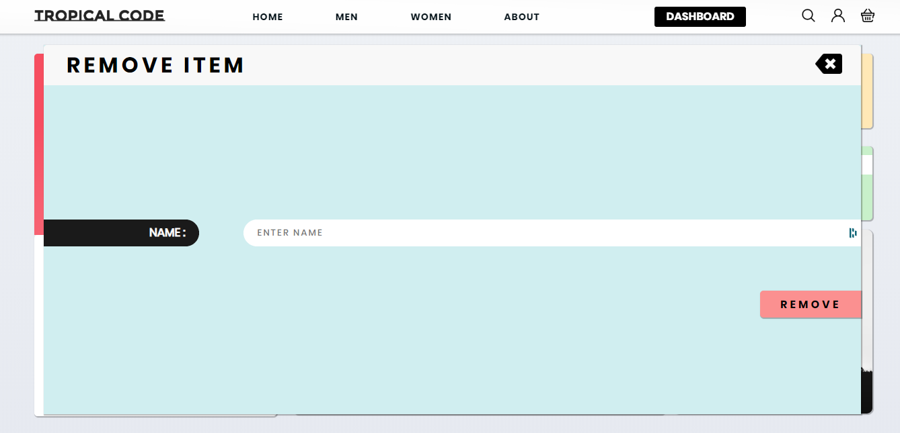

Figure

###### Update User

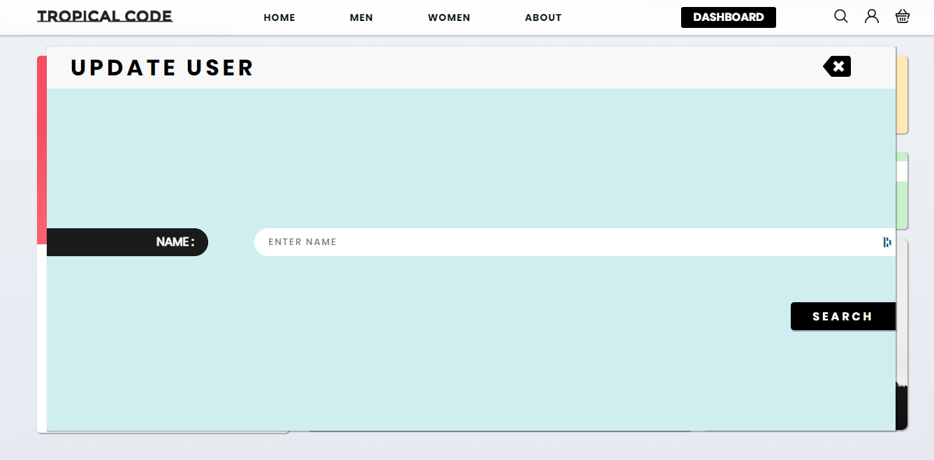

Figure

###### View User

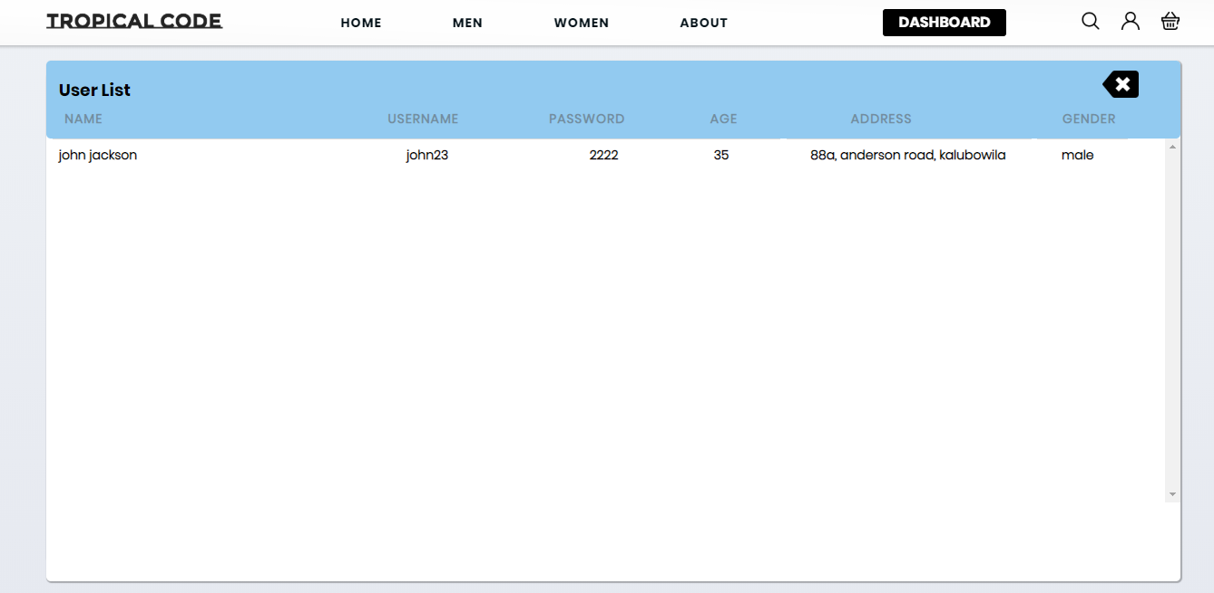

Figure

##### Add Item

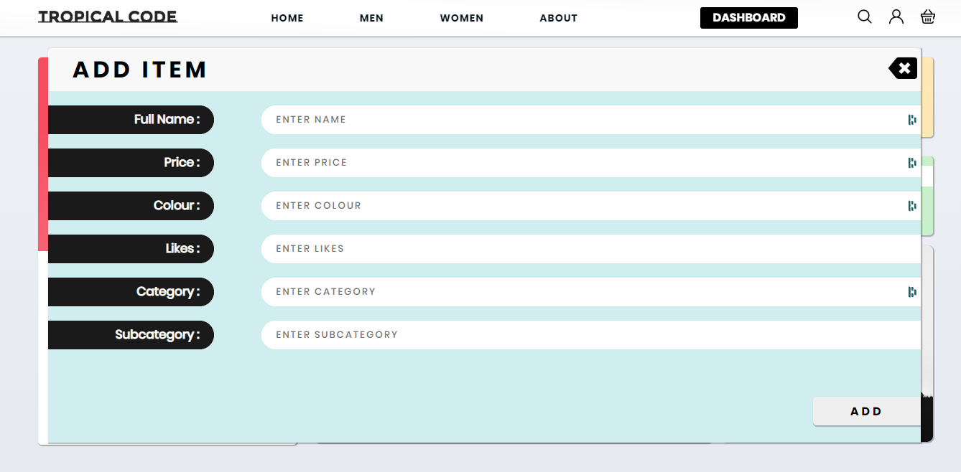

Figure

##### Remove Item



Figure

##### Update Item

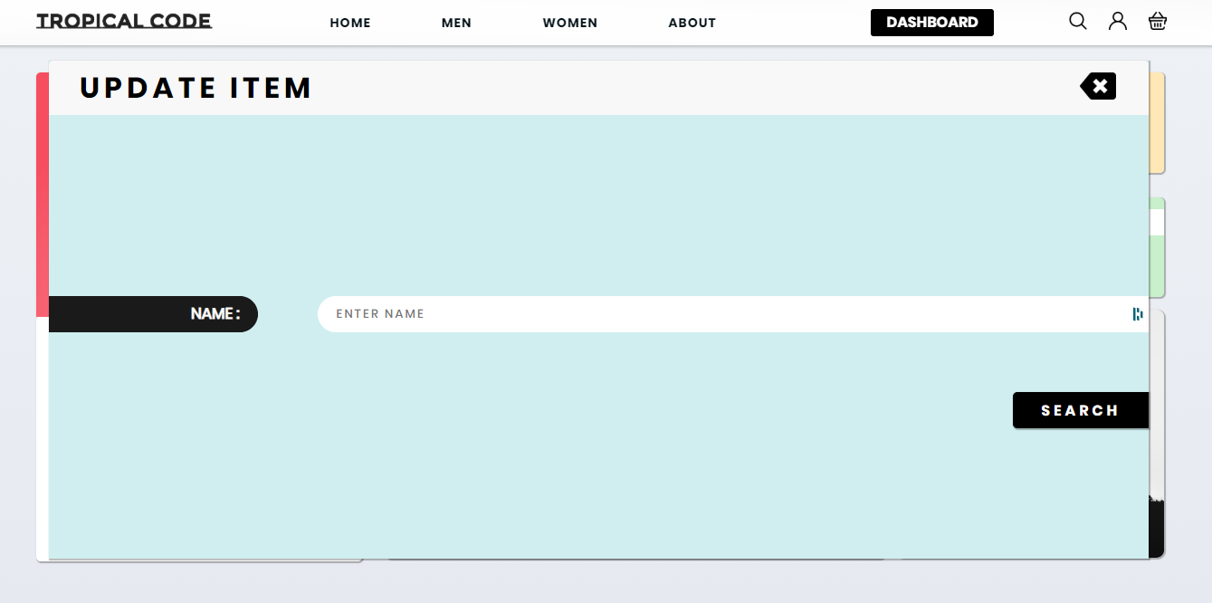

Figure

##### View All Item

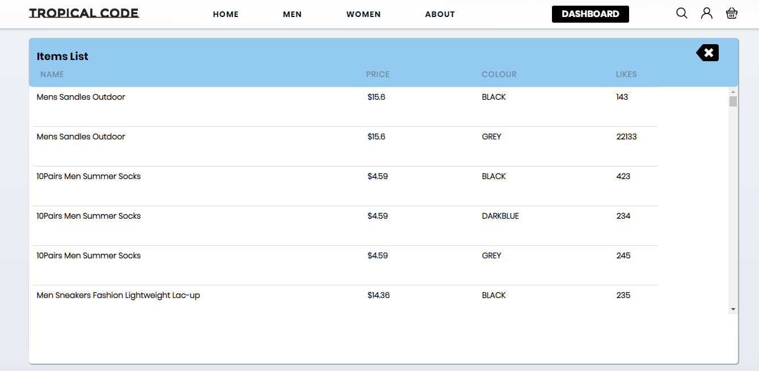

Figure

### Code Snippet

In the folder in the name of “admin.png”

### Men Page

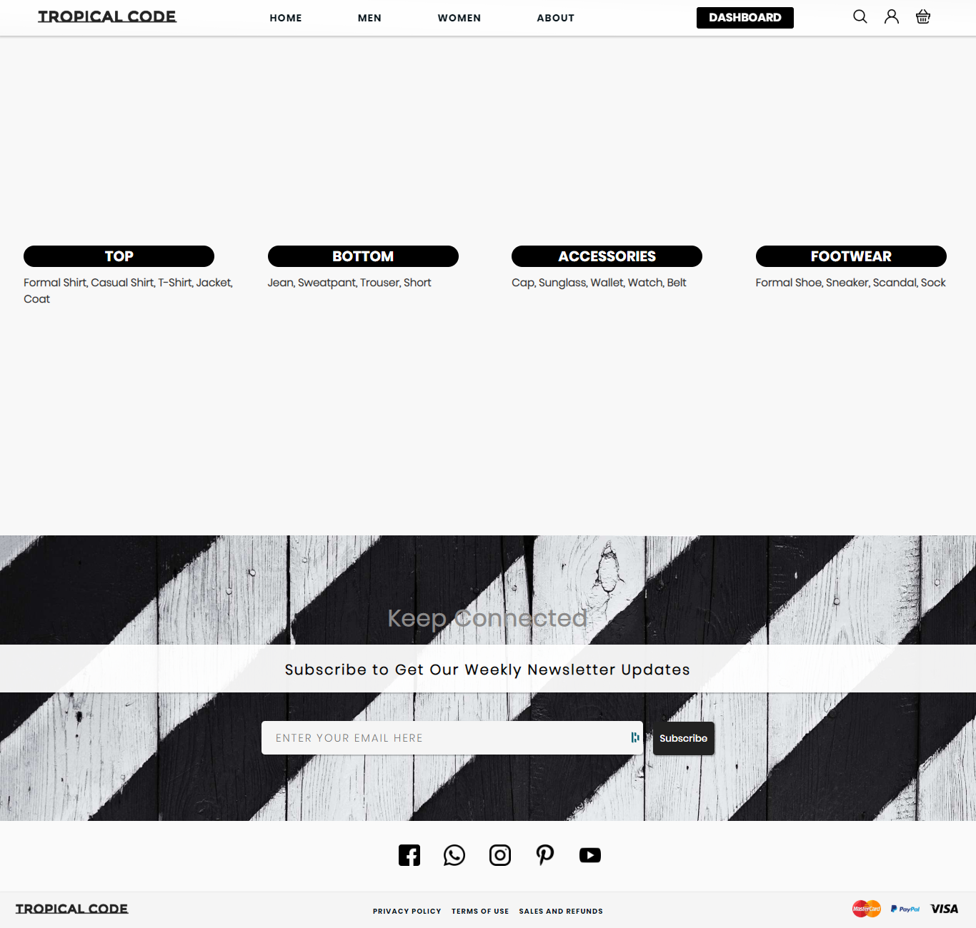

Figure

The men page has the categorized option which has the top, bottom, accessories, footwear menu for users to select from.

### Code Snippet

In the folder in the name of “men.png”

### Top Page

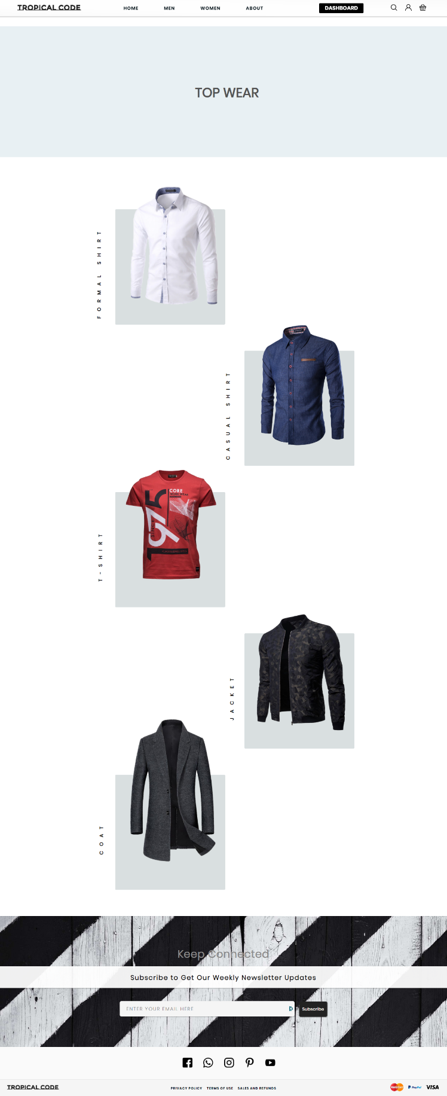

Figure

The top page has the categorized option for users to select from.

### Code Snippet

In the folder in the name of “m-top.png”

#### Formal Shirt

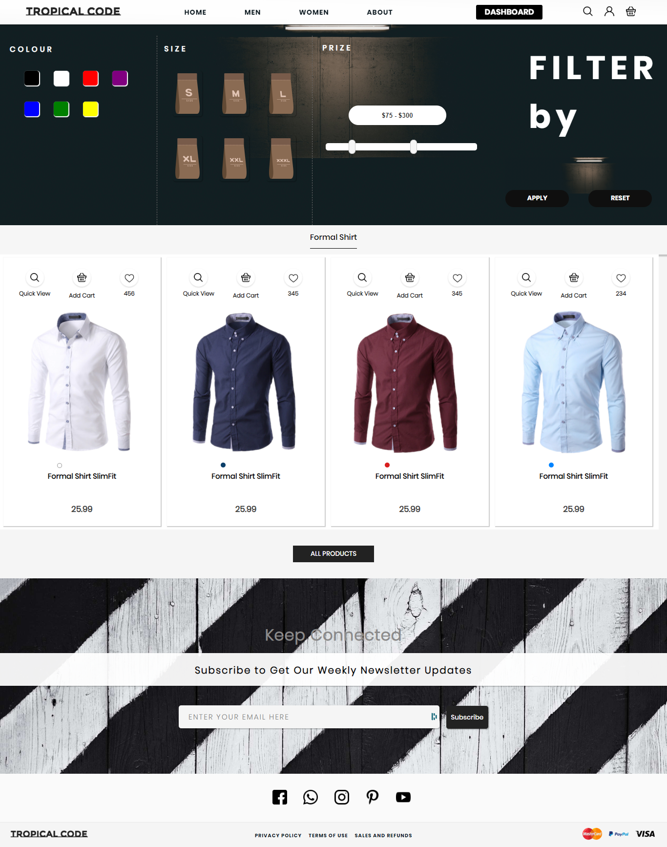

Figure

### Code Snippet

In the folder in the name of “m-formal-shirt.png”

#### Casual Shirt

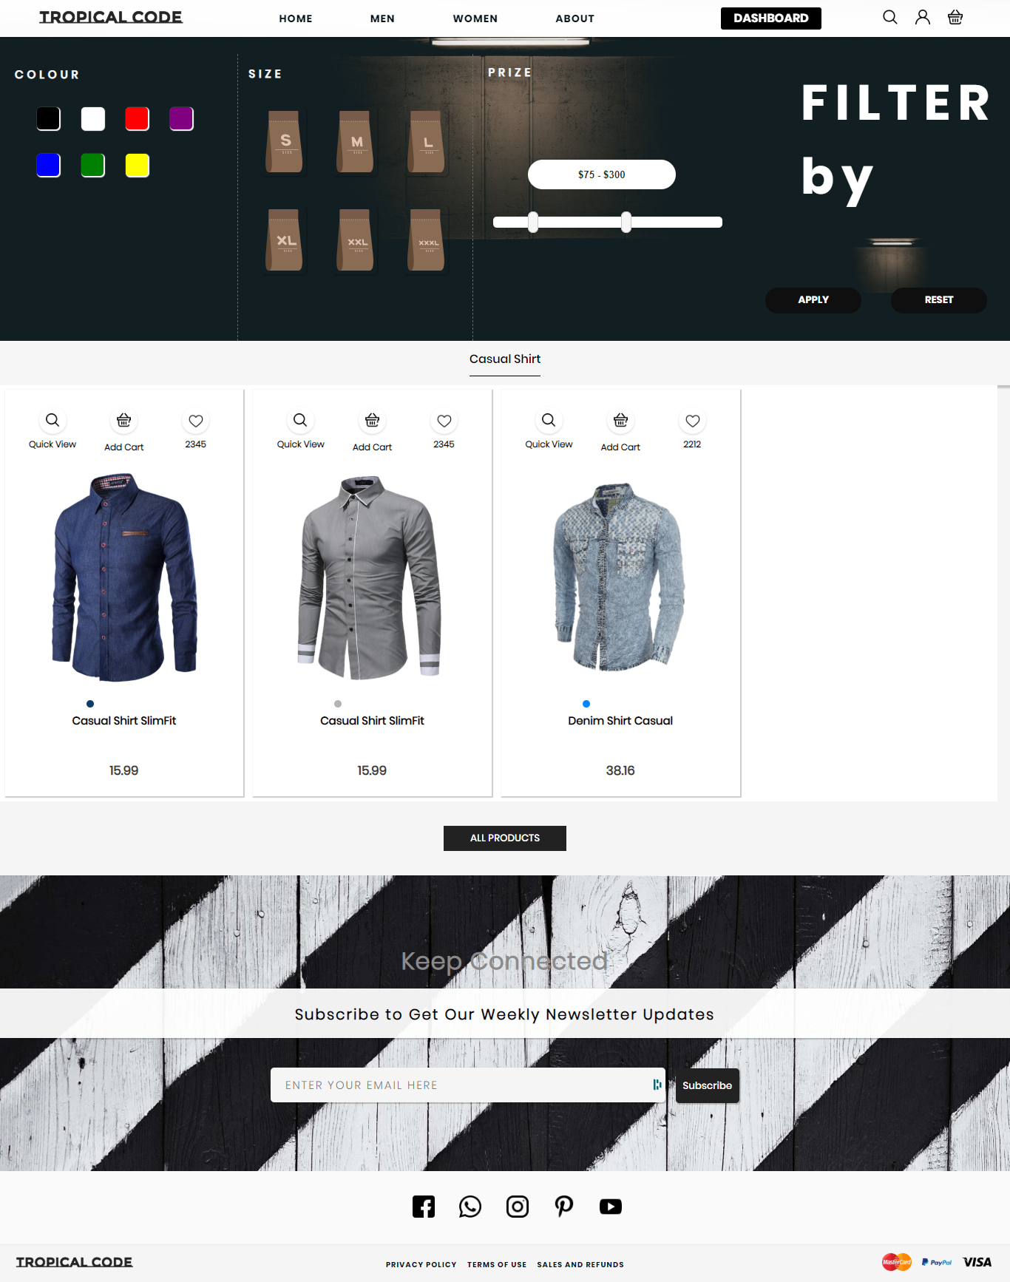

Figure

### Code Snippet

In the folder in the name of “m-casual-shirt.png”

#### T-Shirt

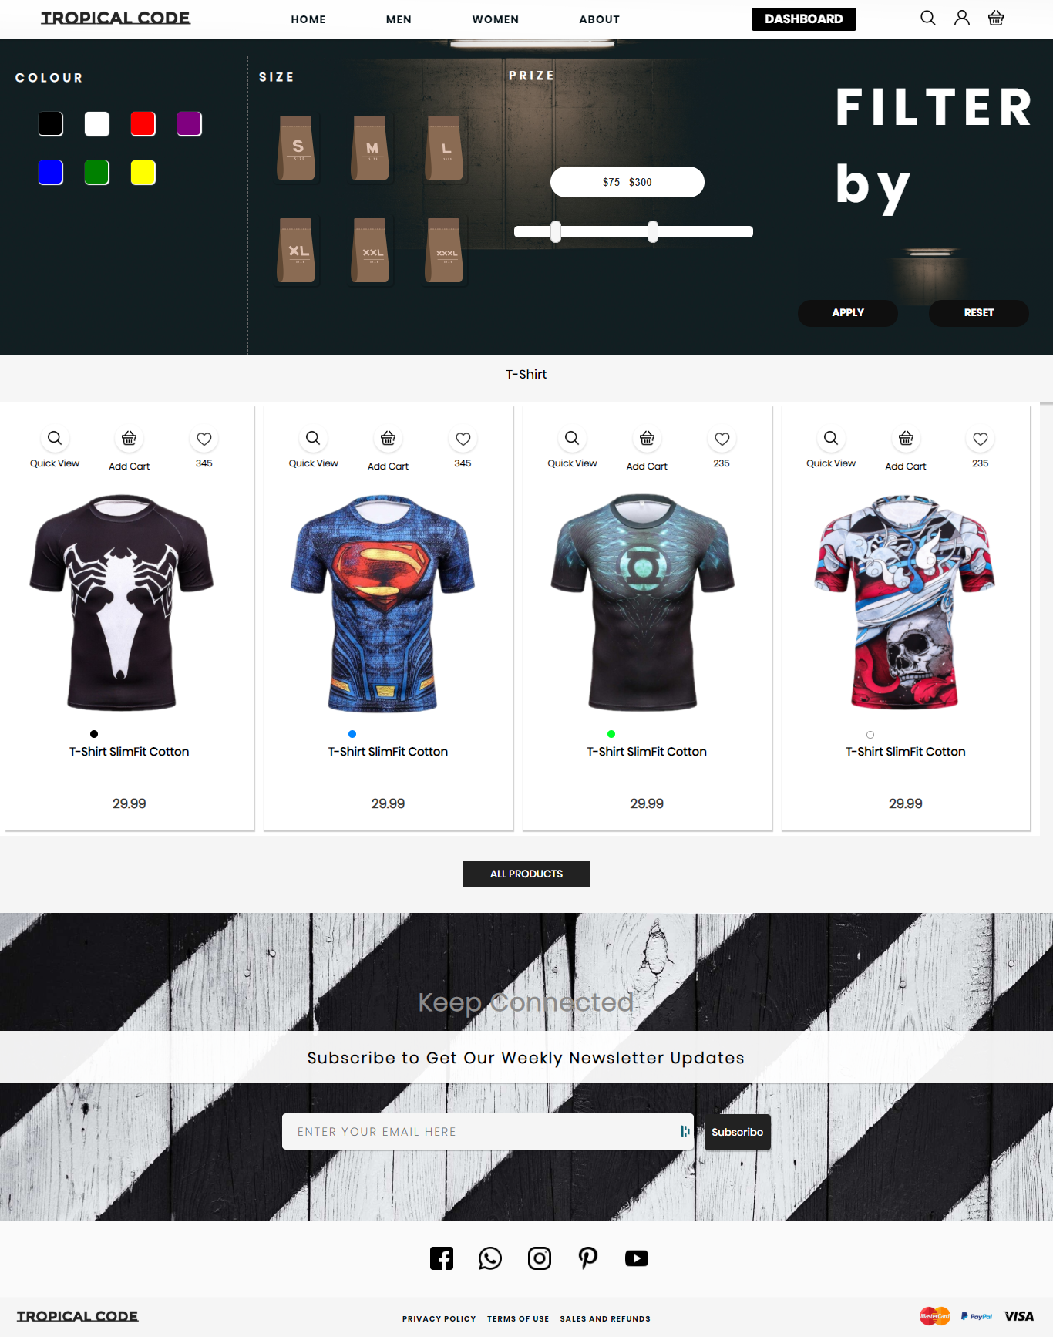

Figure

### Code Snippet

In the folder in the name of “m-t-shirt.png”

#### Jacket

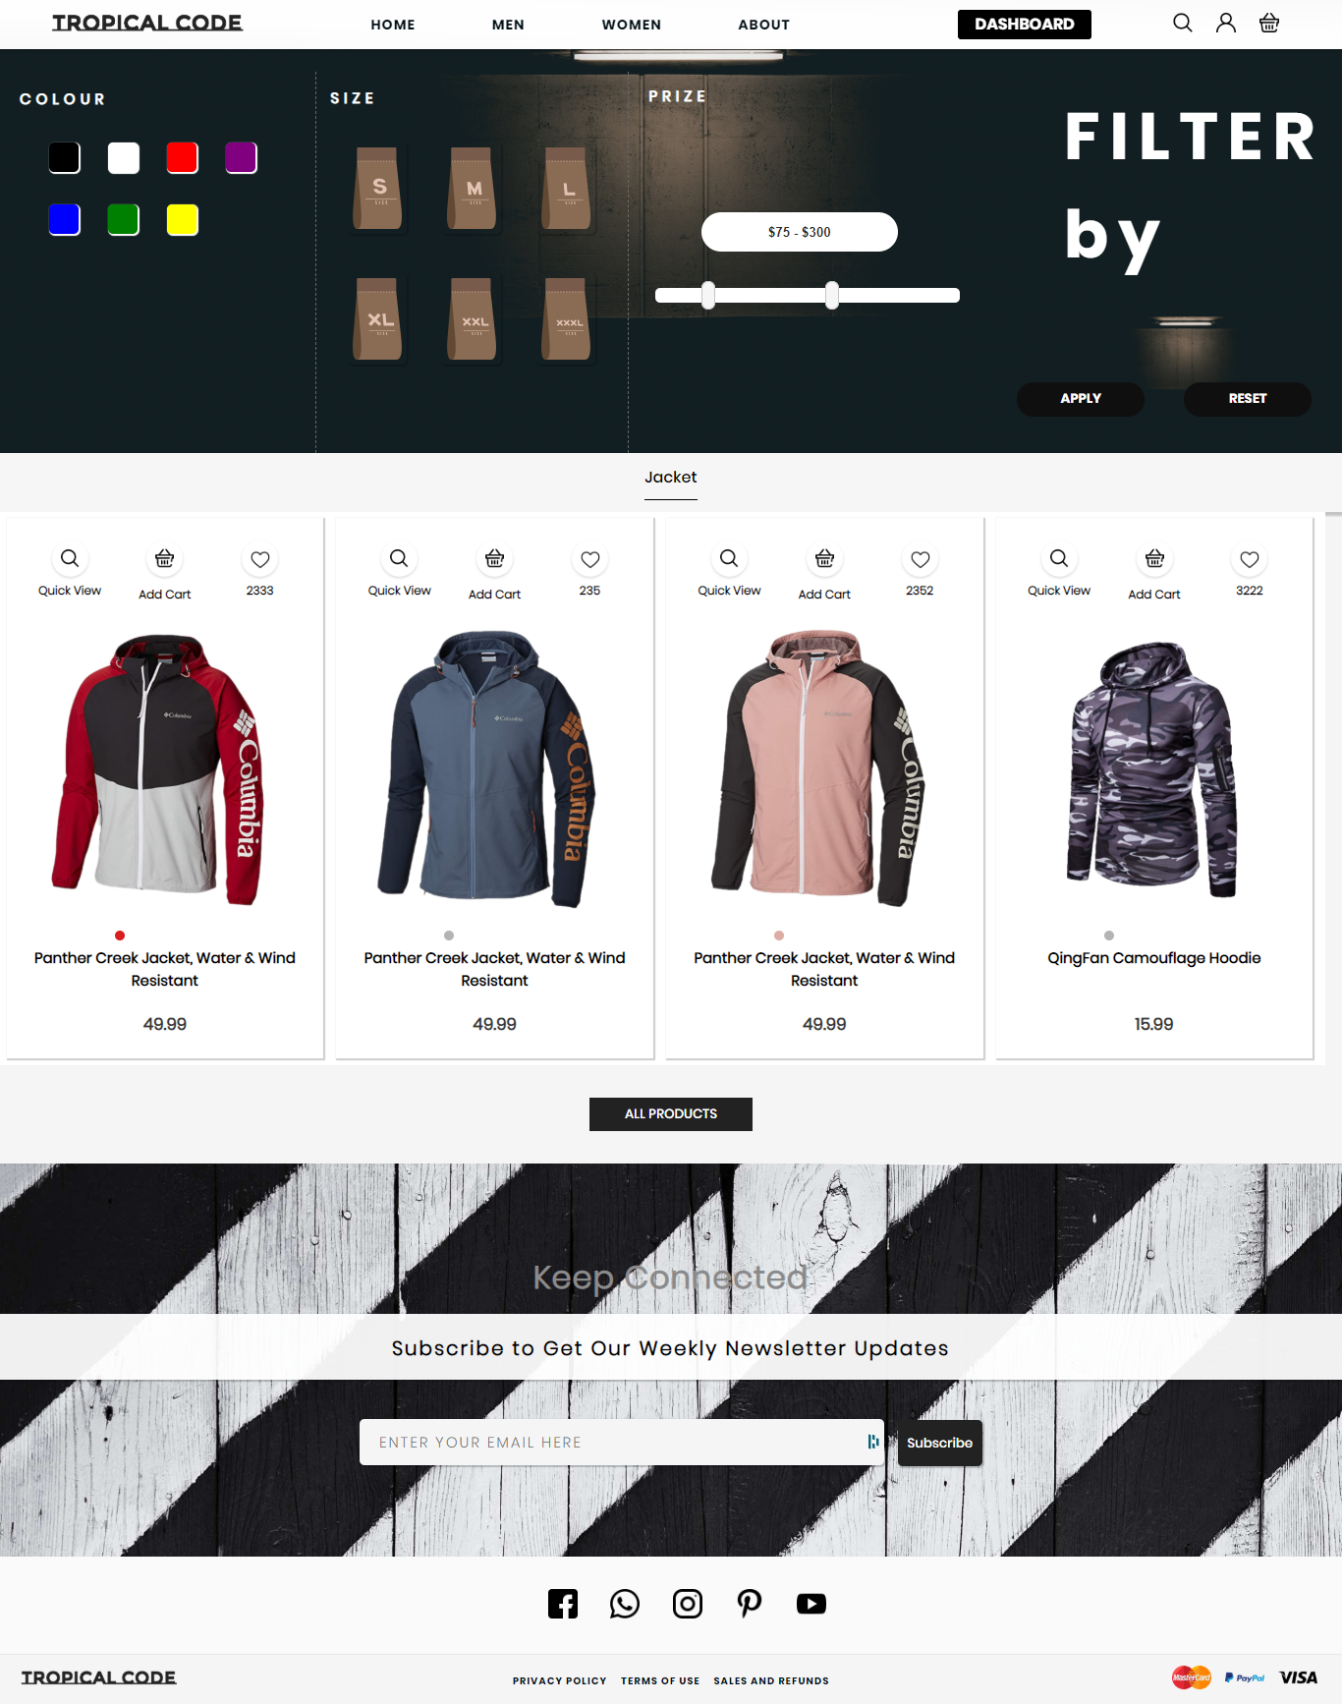

Figure

### Code Snippet

In the folder in the name of “m-jacket.png”

#### Coat

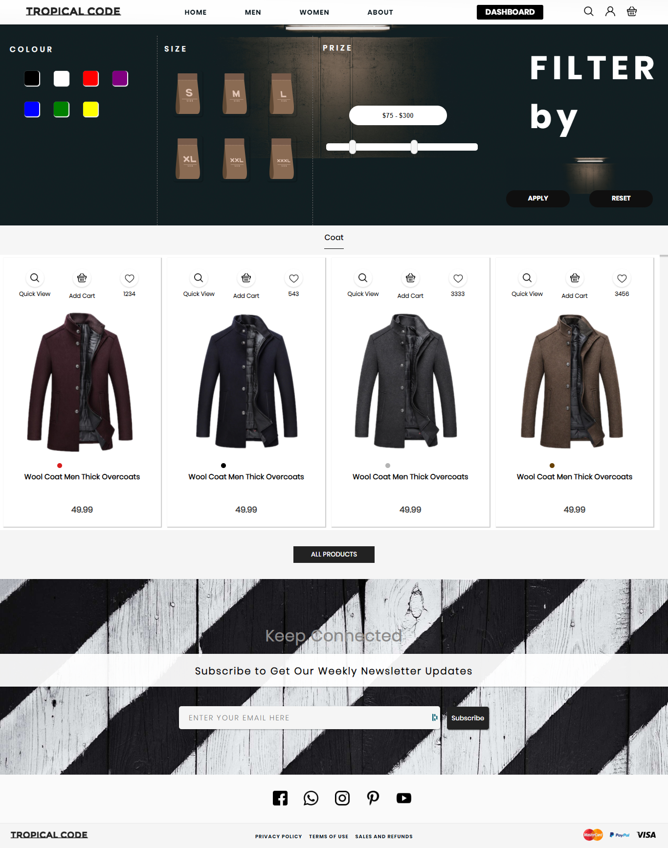

Figure

### Code Snippet

In the folder in the name of “m-coat.png”

### Bottom Page

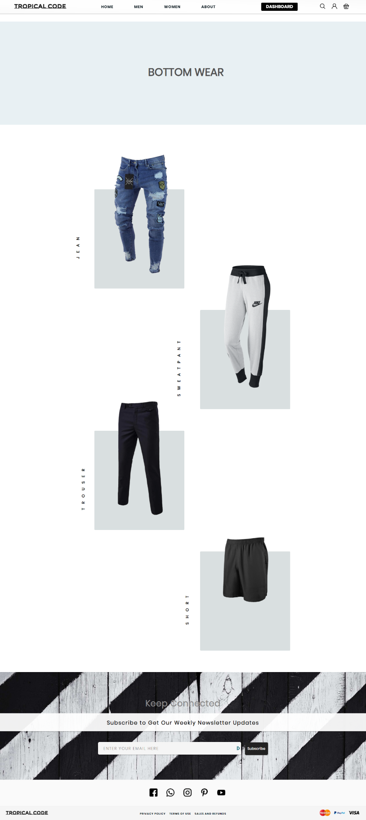

Figure

The bottom page has the categorized option for users to select from.

### Code Snippet

In the folder in the name of “m-bottom.png”

#### Jean

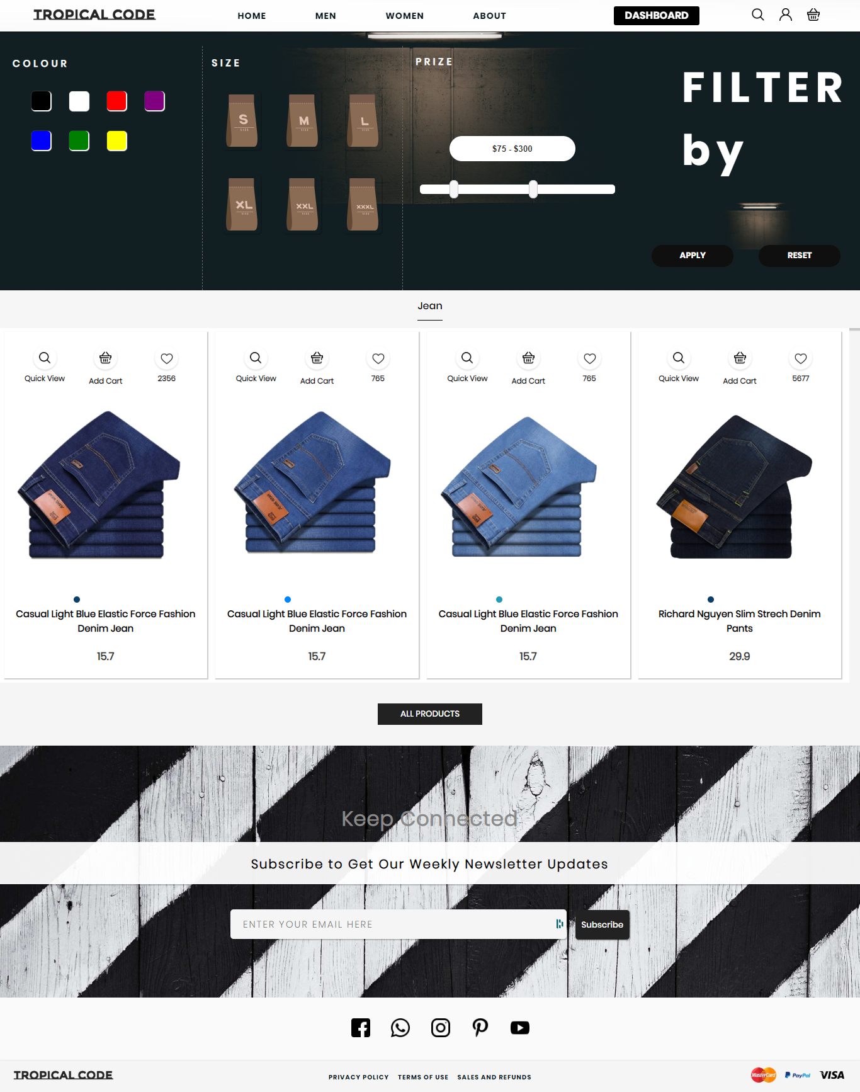

Figure

### Code Snippet

In the folder in the name of “m-jean.png”

#### Sweatpants

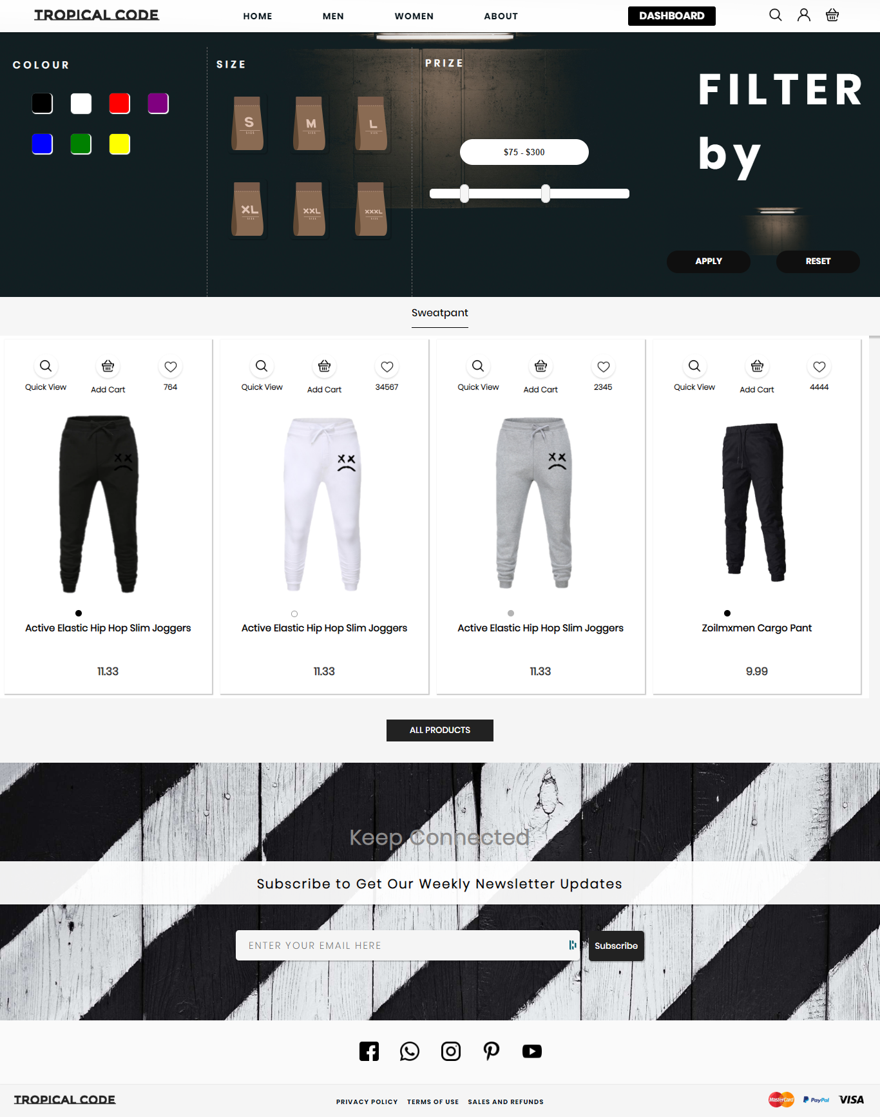

Figure

### Code Snippet

In the folder in the name of “m-sweatpant.png”

#### Trouser

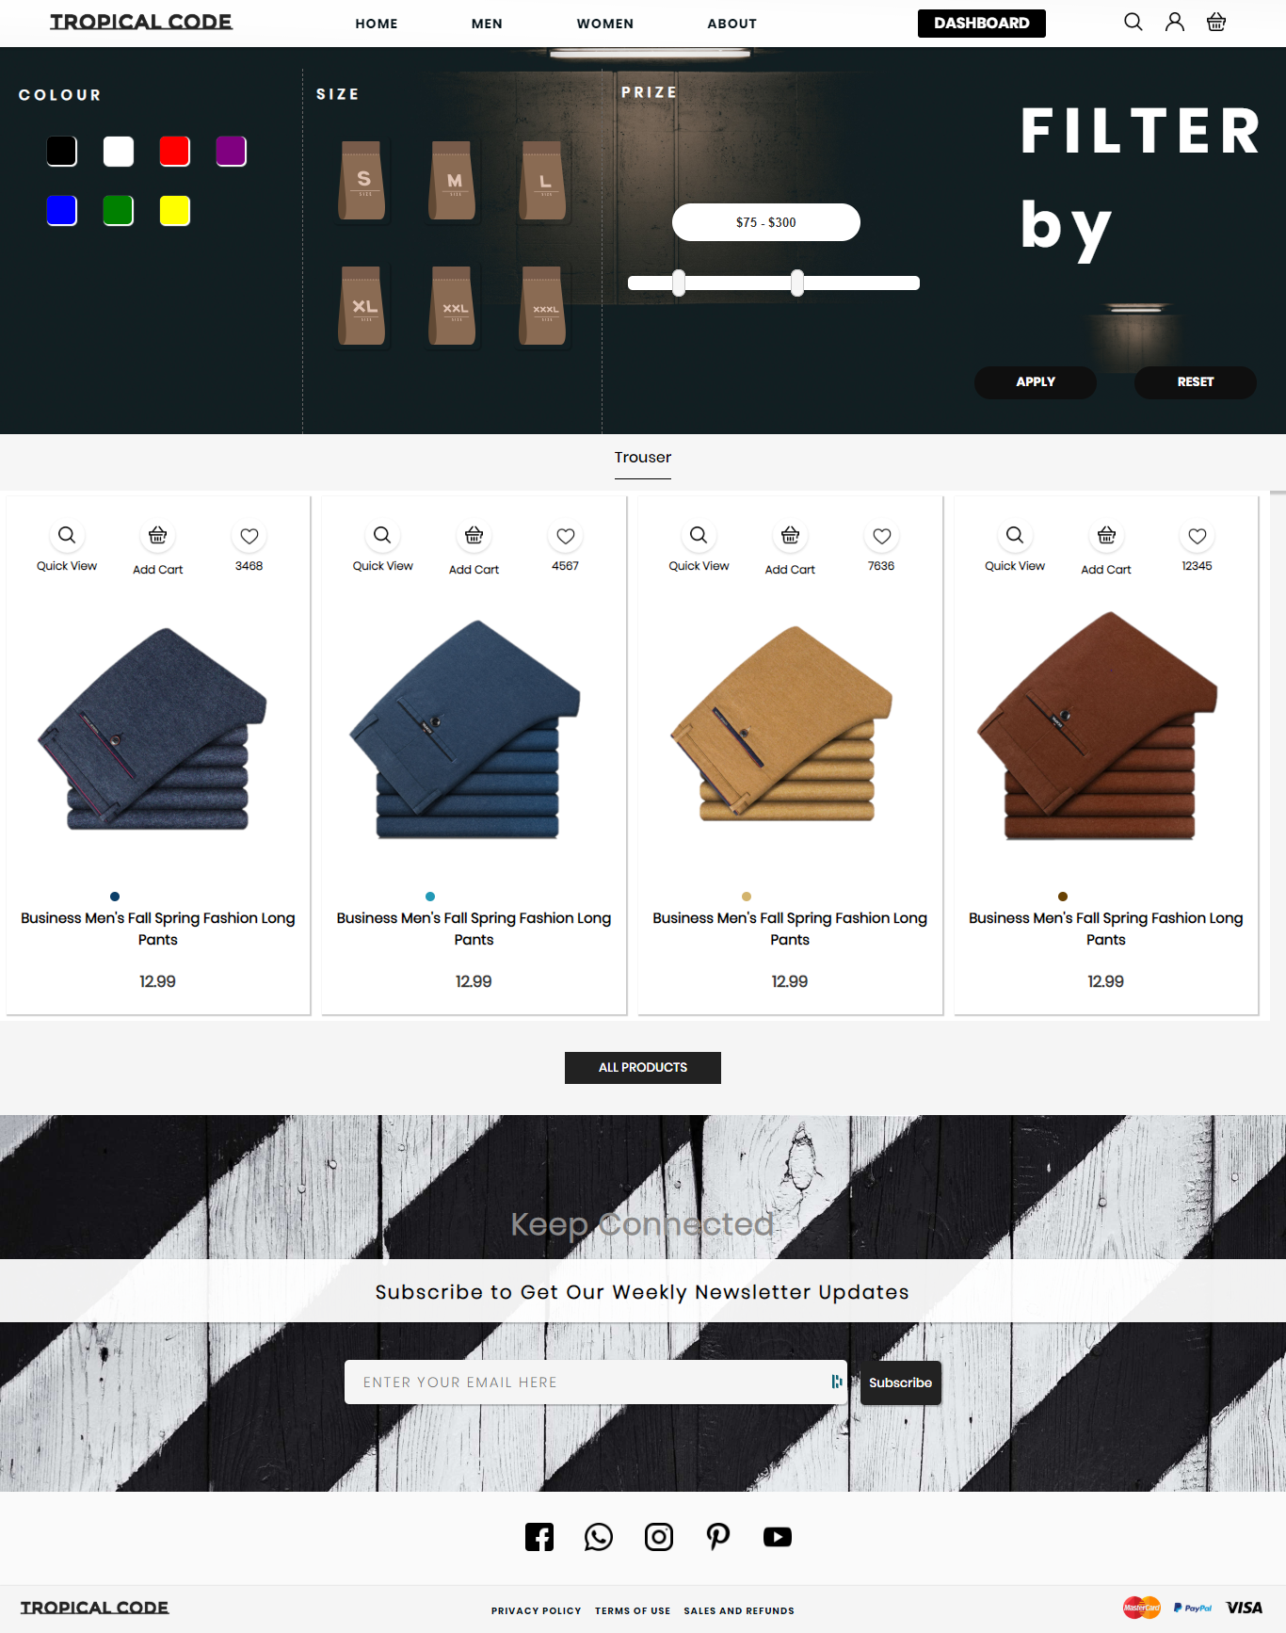

Figure

### Code Snippet

In the folder in the name of “m-trouser.png”

#### Short

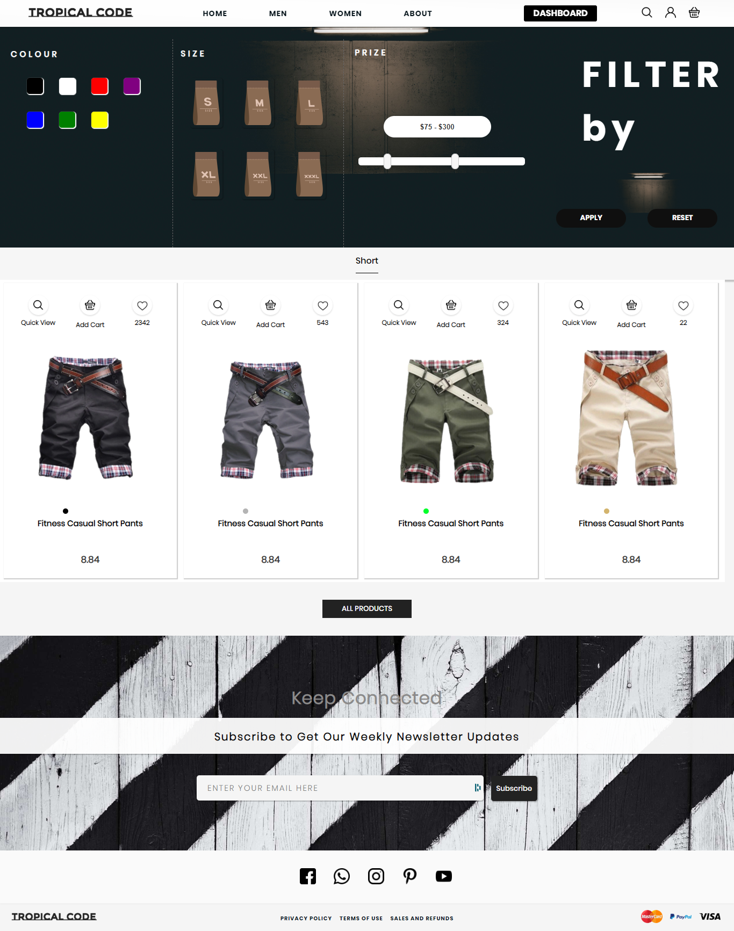

Figure

### Code Snippet

In the folder in the name of “m-short.png”

### Accessories Page

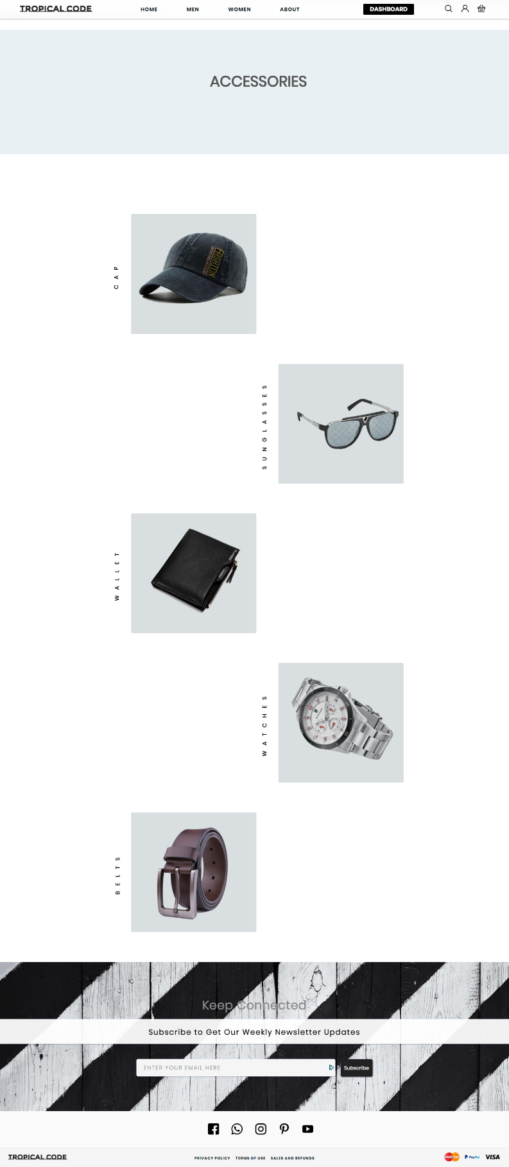

Figure

The accessories page has the categorized option for users to select from.

### Code Snippet

In the folder in the name of “m-accessories.png”

#### Cap

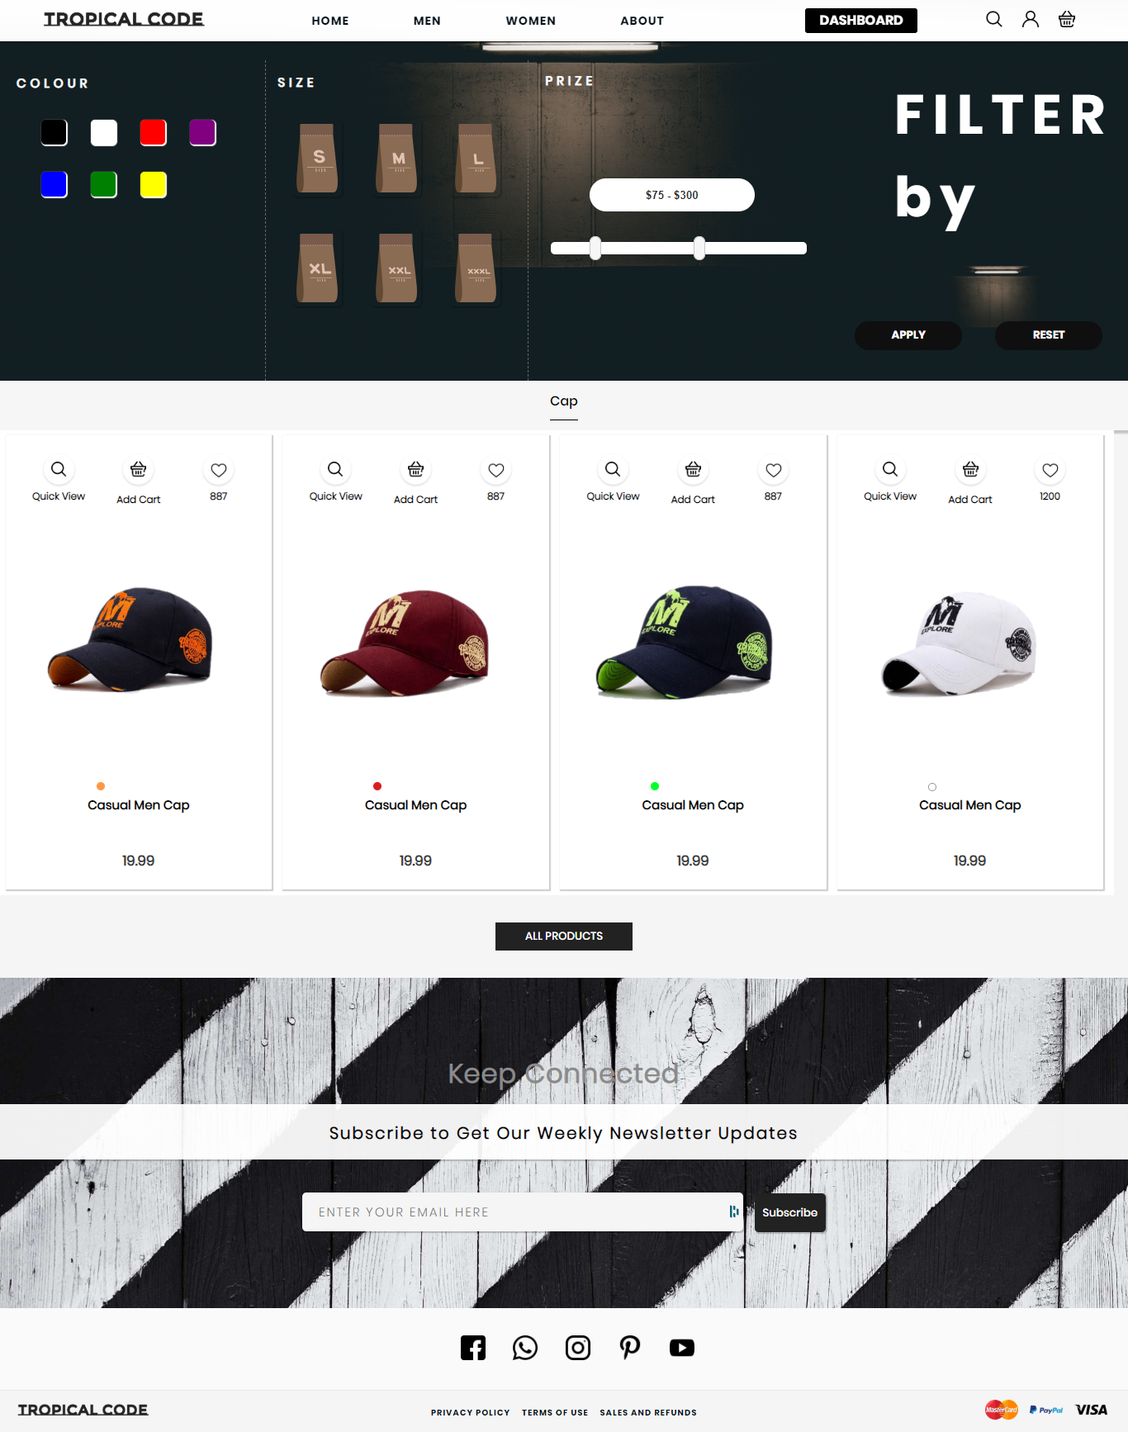

Figure

### Code Snippet

In the folder in the name of “m-cap.png”

#### Sunglass

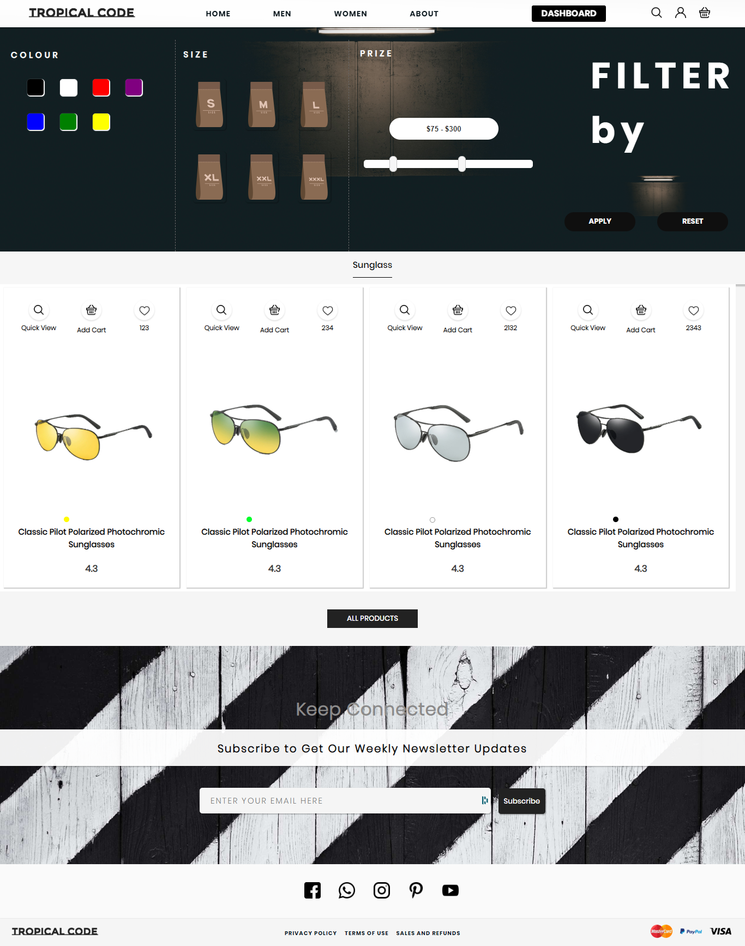

Figure

### Code Snippet

In the folder in the name of “m-sunglass.png”

#### Wallet

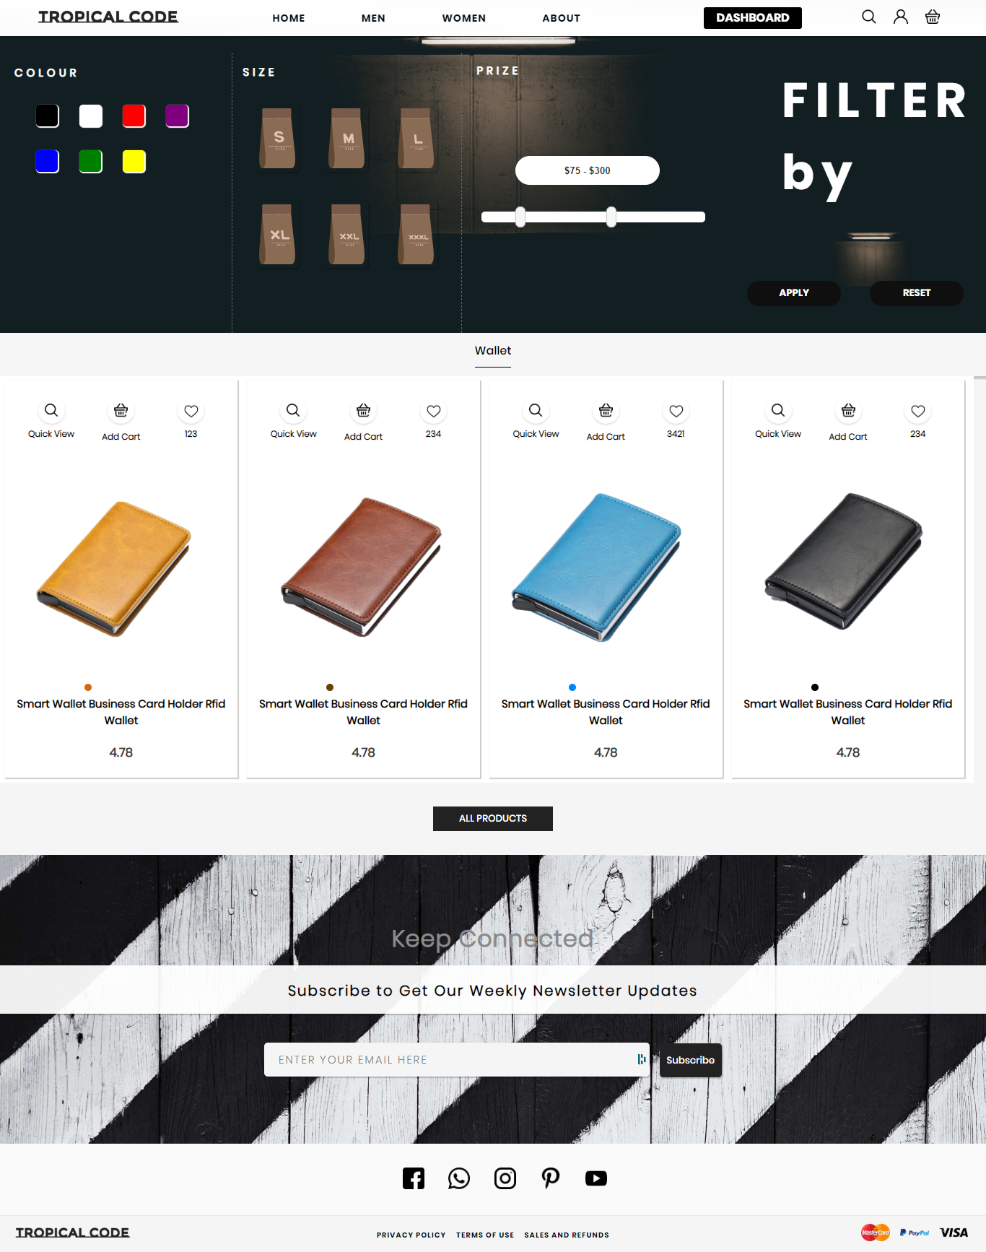

Figure

### Code Snippet

In the folder in the name of “m-wallet.png”

#### Watch

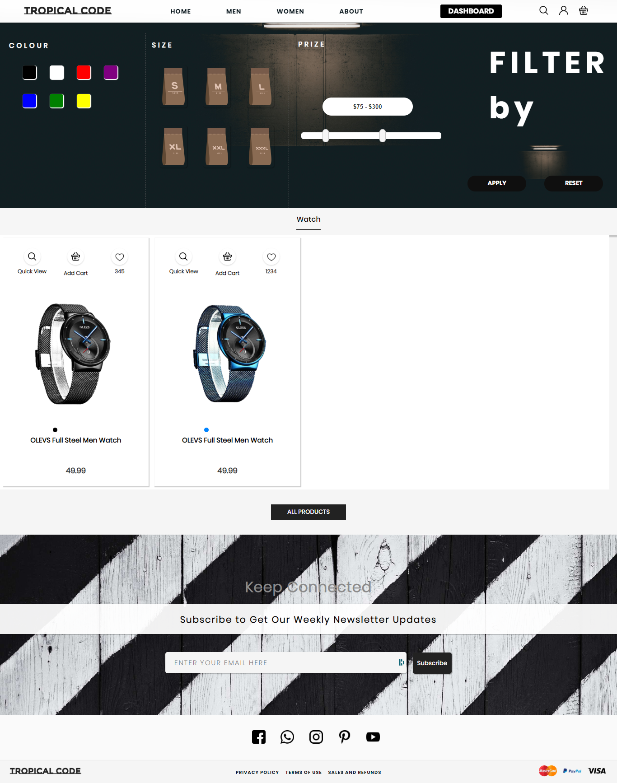

Figure

### Code Snippet

In the folder in the name of “m-watch.png”

#### Belt

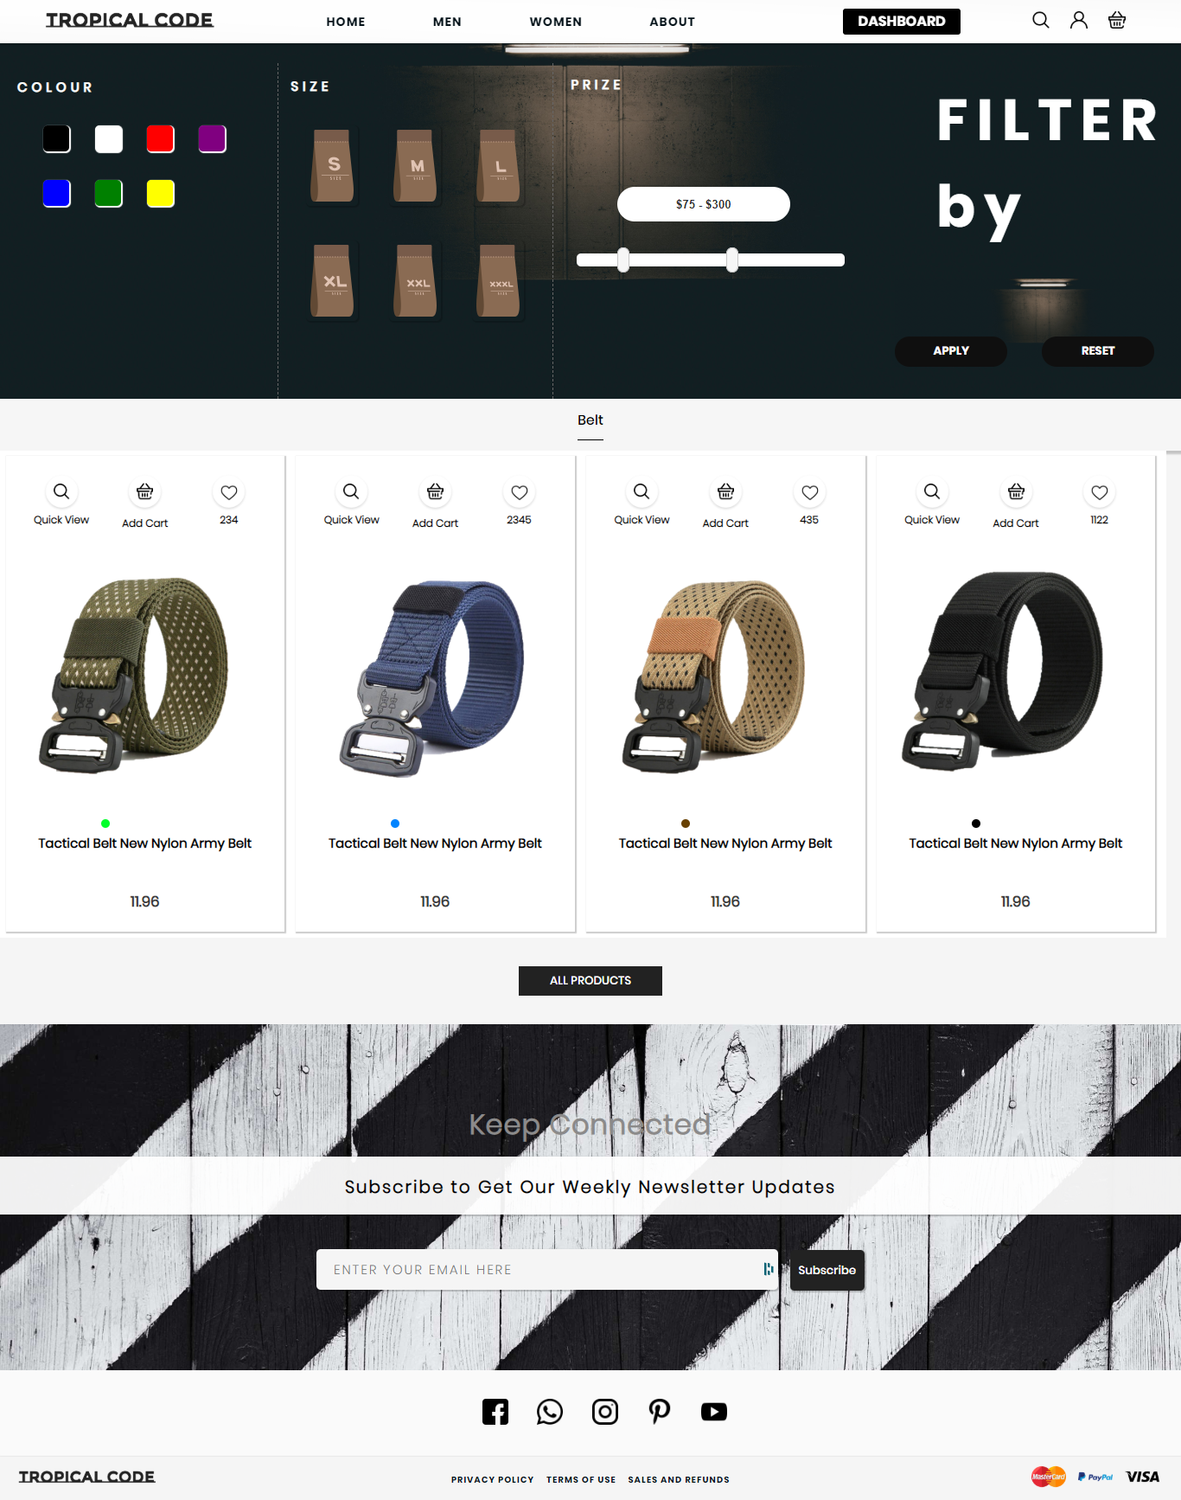

Figure

### Code Snippet

In the folder in the name of “m-belt.png”

### Footwear Page

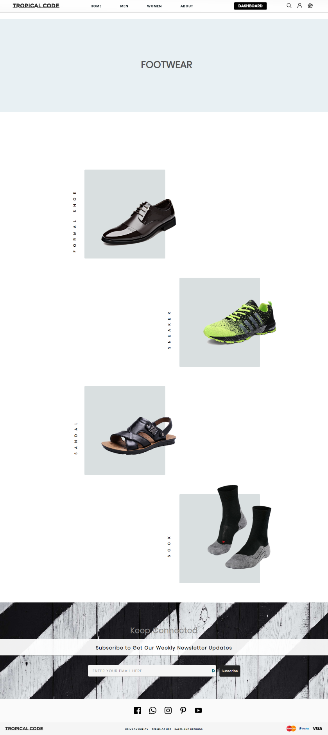

Figure

The footwear page has the categorized option for users to select from.

### Code Snippet

In the folder in the name of “m-footer.png”

#### Formal Shoe

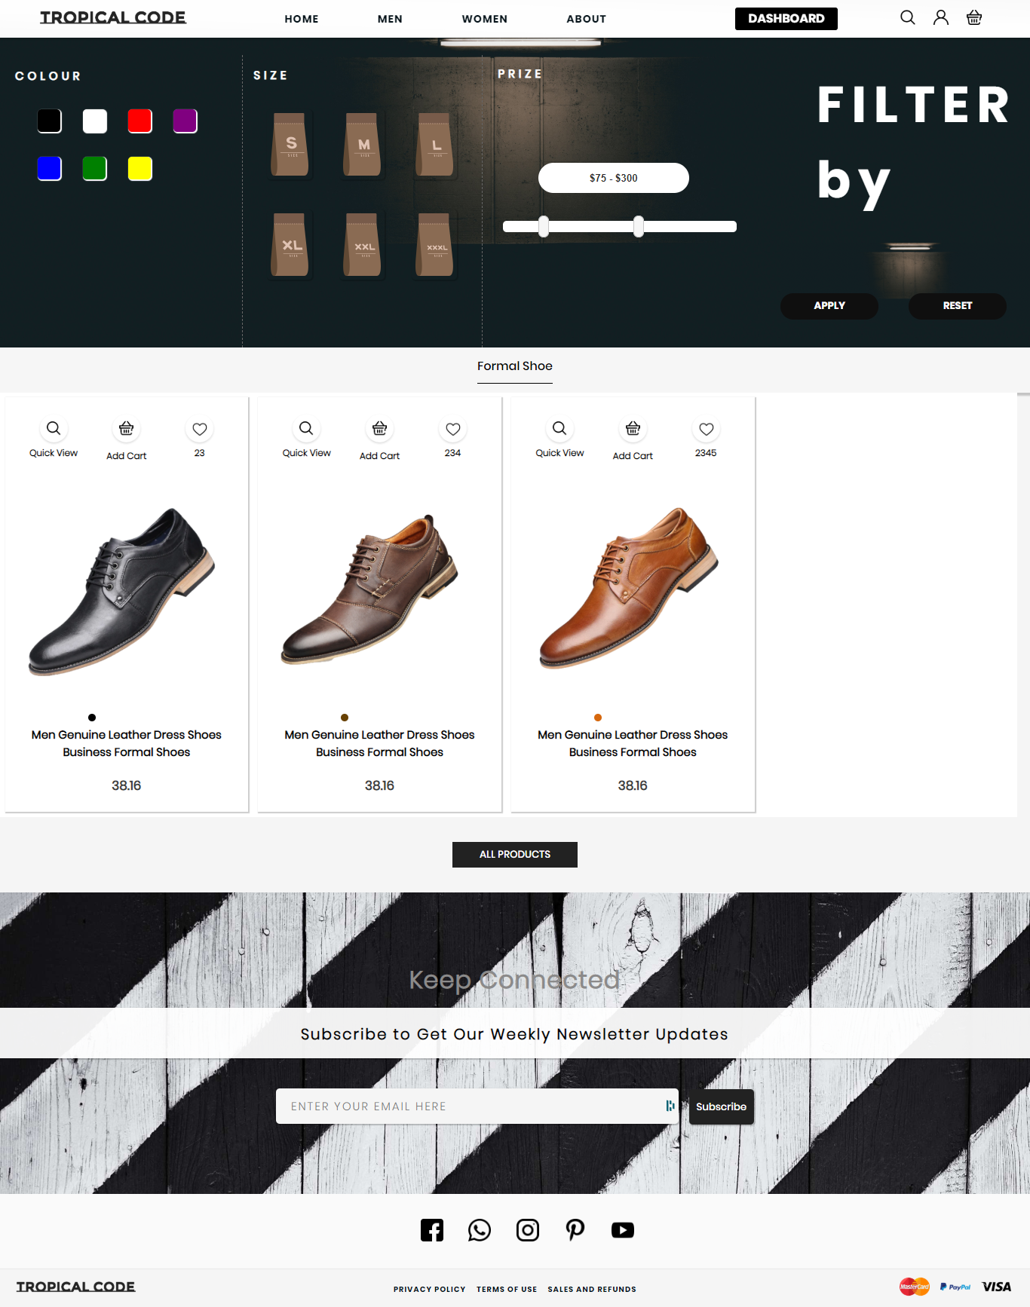

Figure

### Code Snippet

In the folder in the name of “m-formal-shoe.png”

#### Sneaker

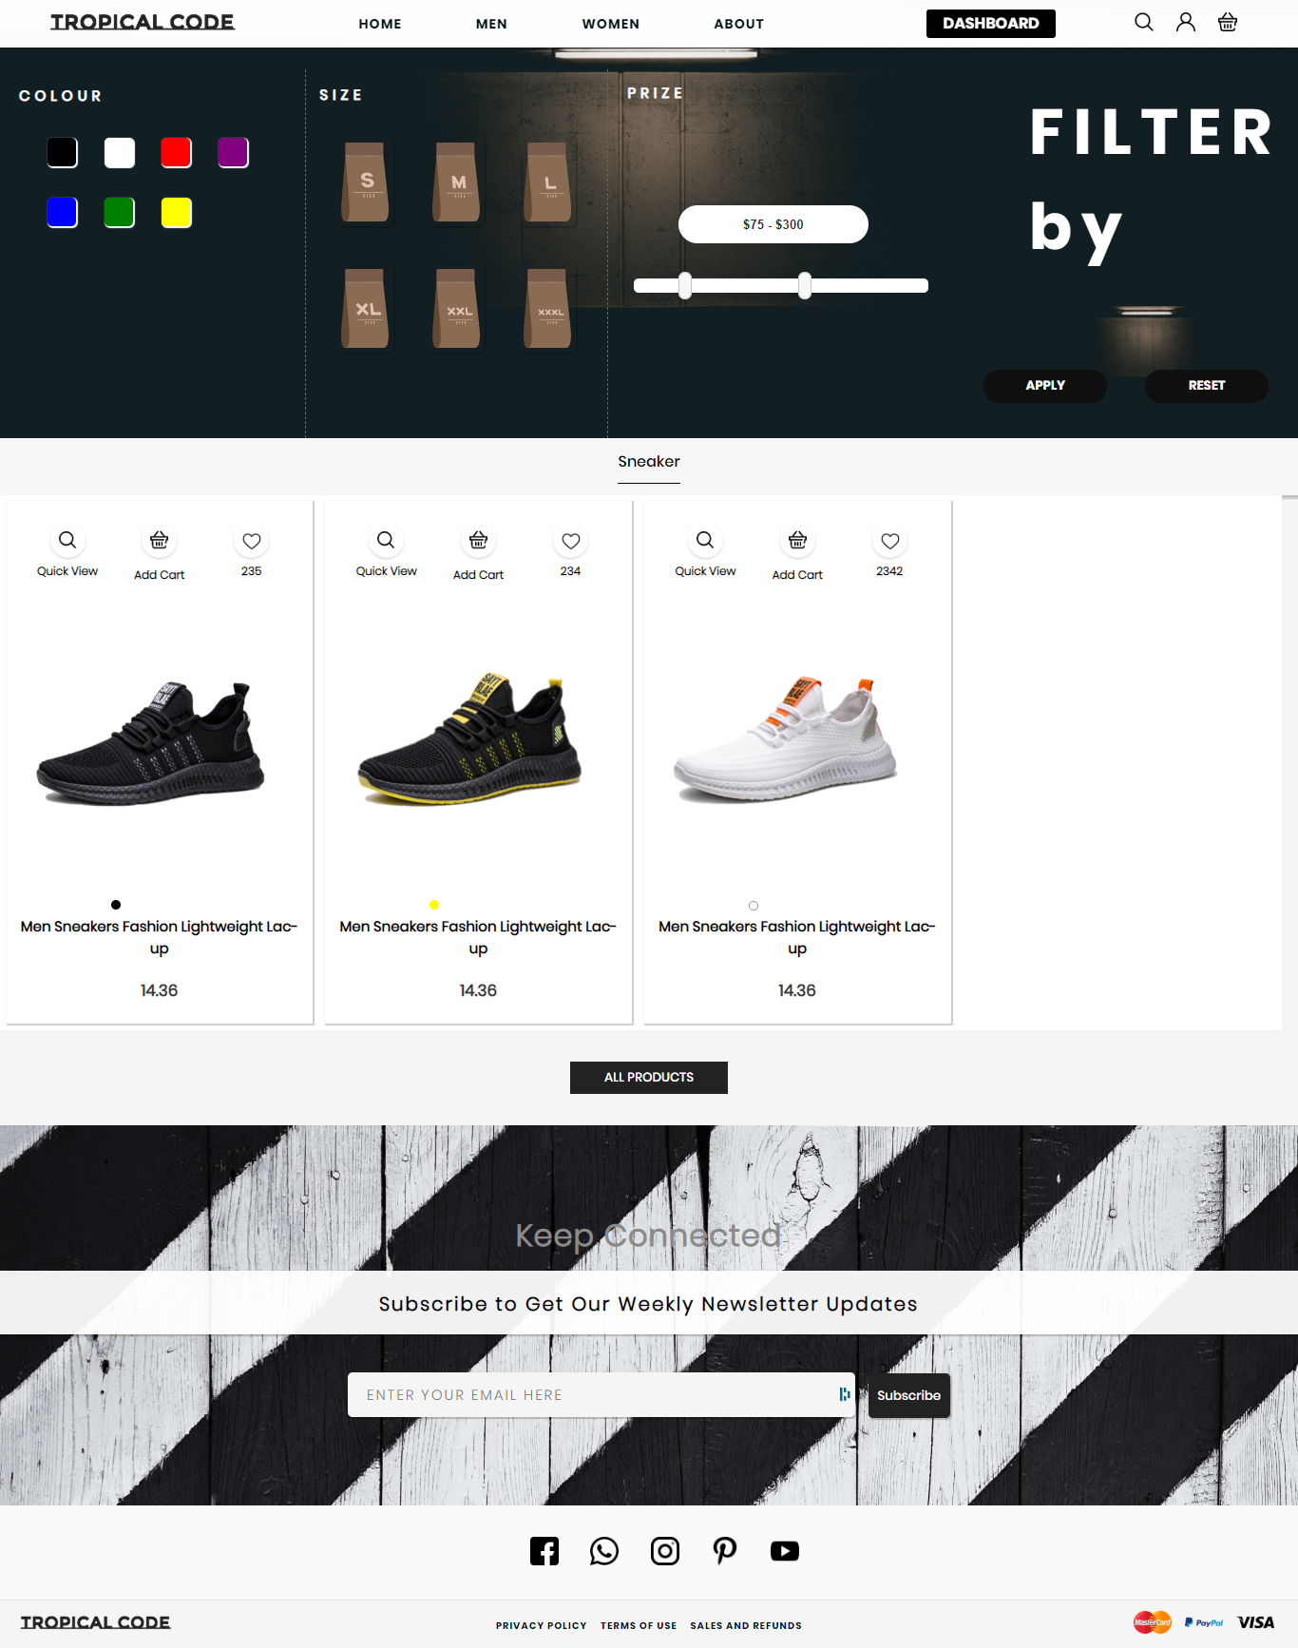

Figure

### Code Snippet

In the folder in the name of “m-sneaker.png”

#### Sandal

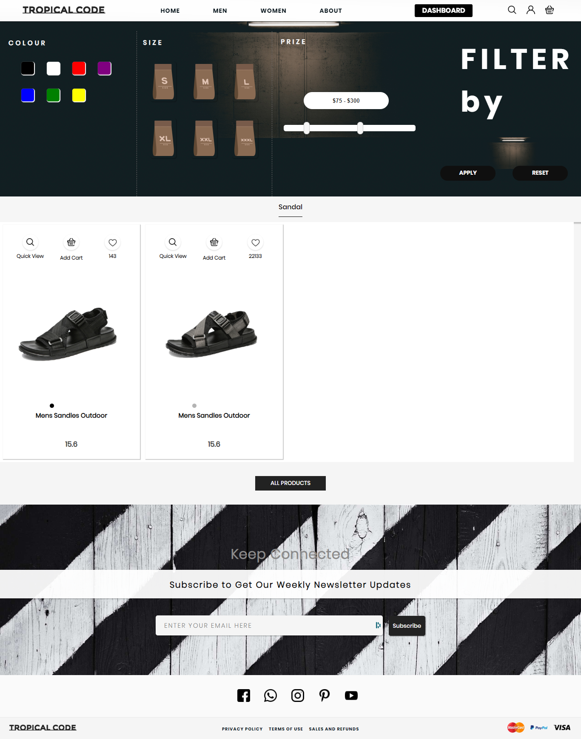

Figure

### Code Snippet

In the folder in the name of “m-sandal.png”

#### Socks

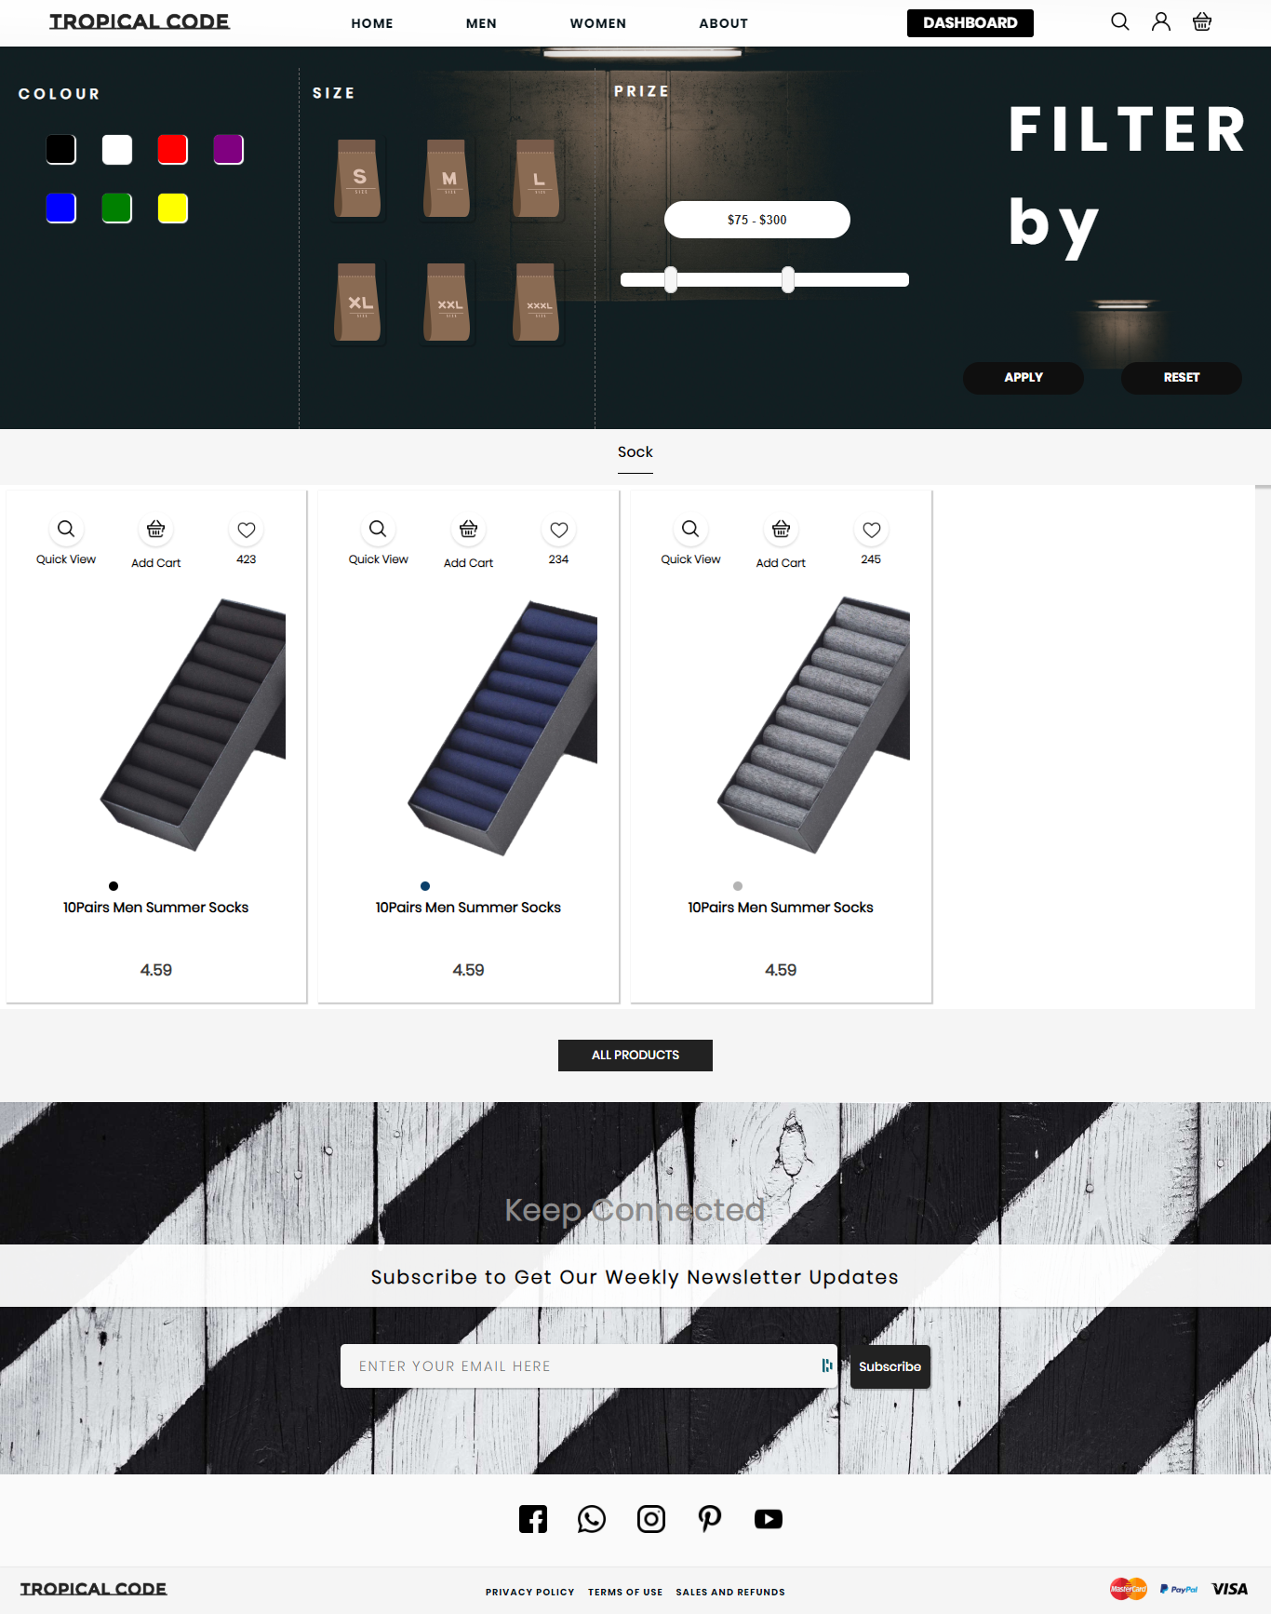

Figure

### Code Snippet

In the folder in the name of “m-sock.png”

### Women Page

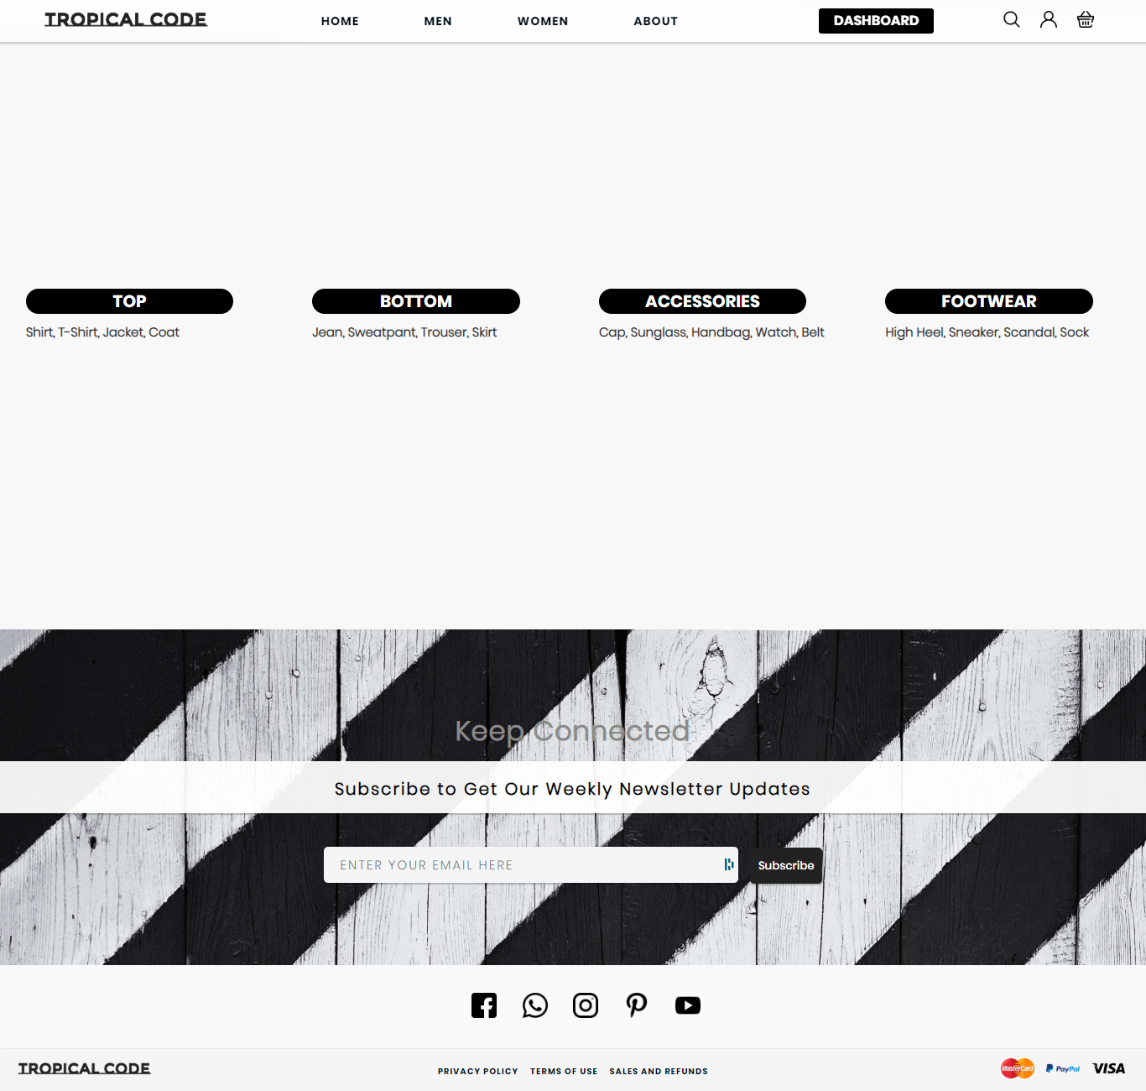

Figure

The women page has the categorized option which has the top, bottom, accessories, footwear menu for users to select from.

### Code Snippet

In the folder in the name of “women.png”

### Top Page

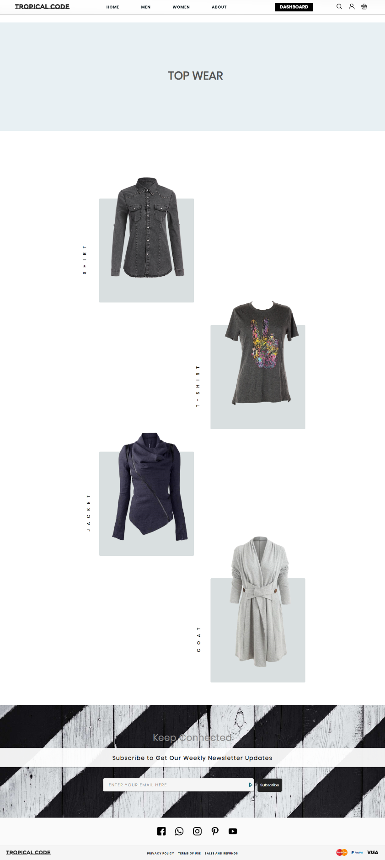

Figure

The top page has the categorized option for users to select from.

### Code Snippet

In the folder in the name of “w-top.png”

#### Shirt

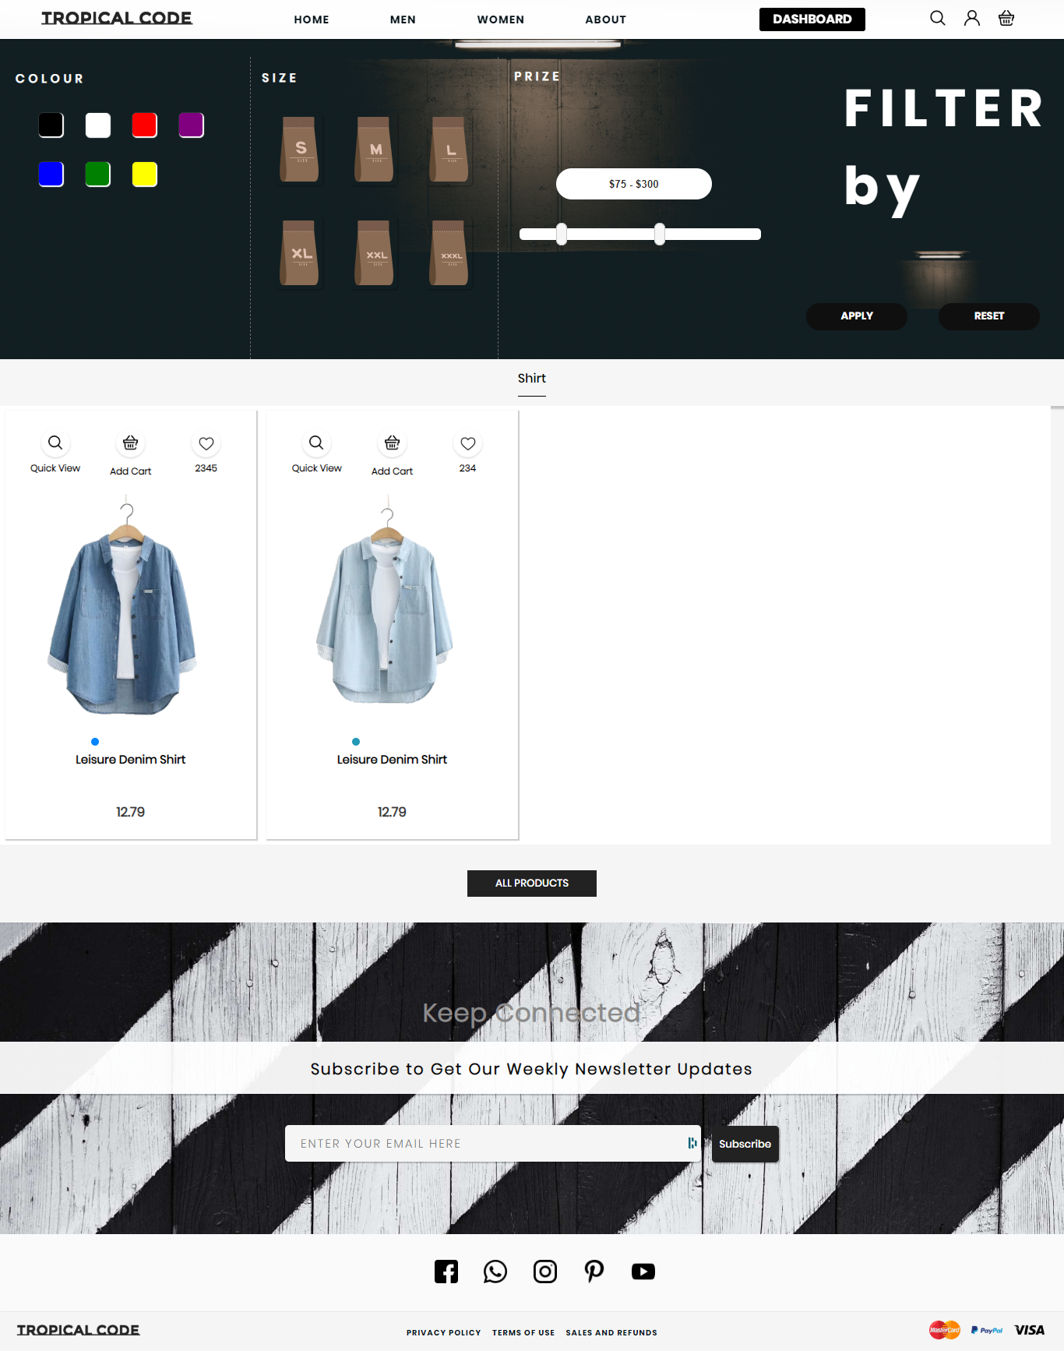

Figure

### Code Snippet

In the folder in the name of “w-shirt.png”

#### T-Shirt

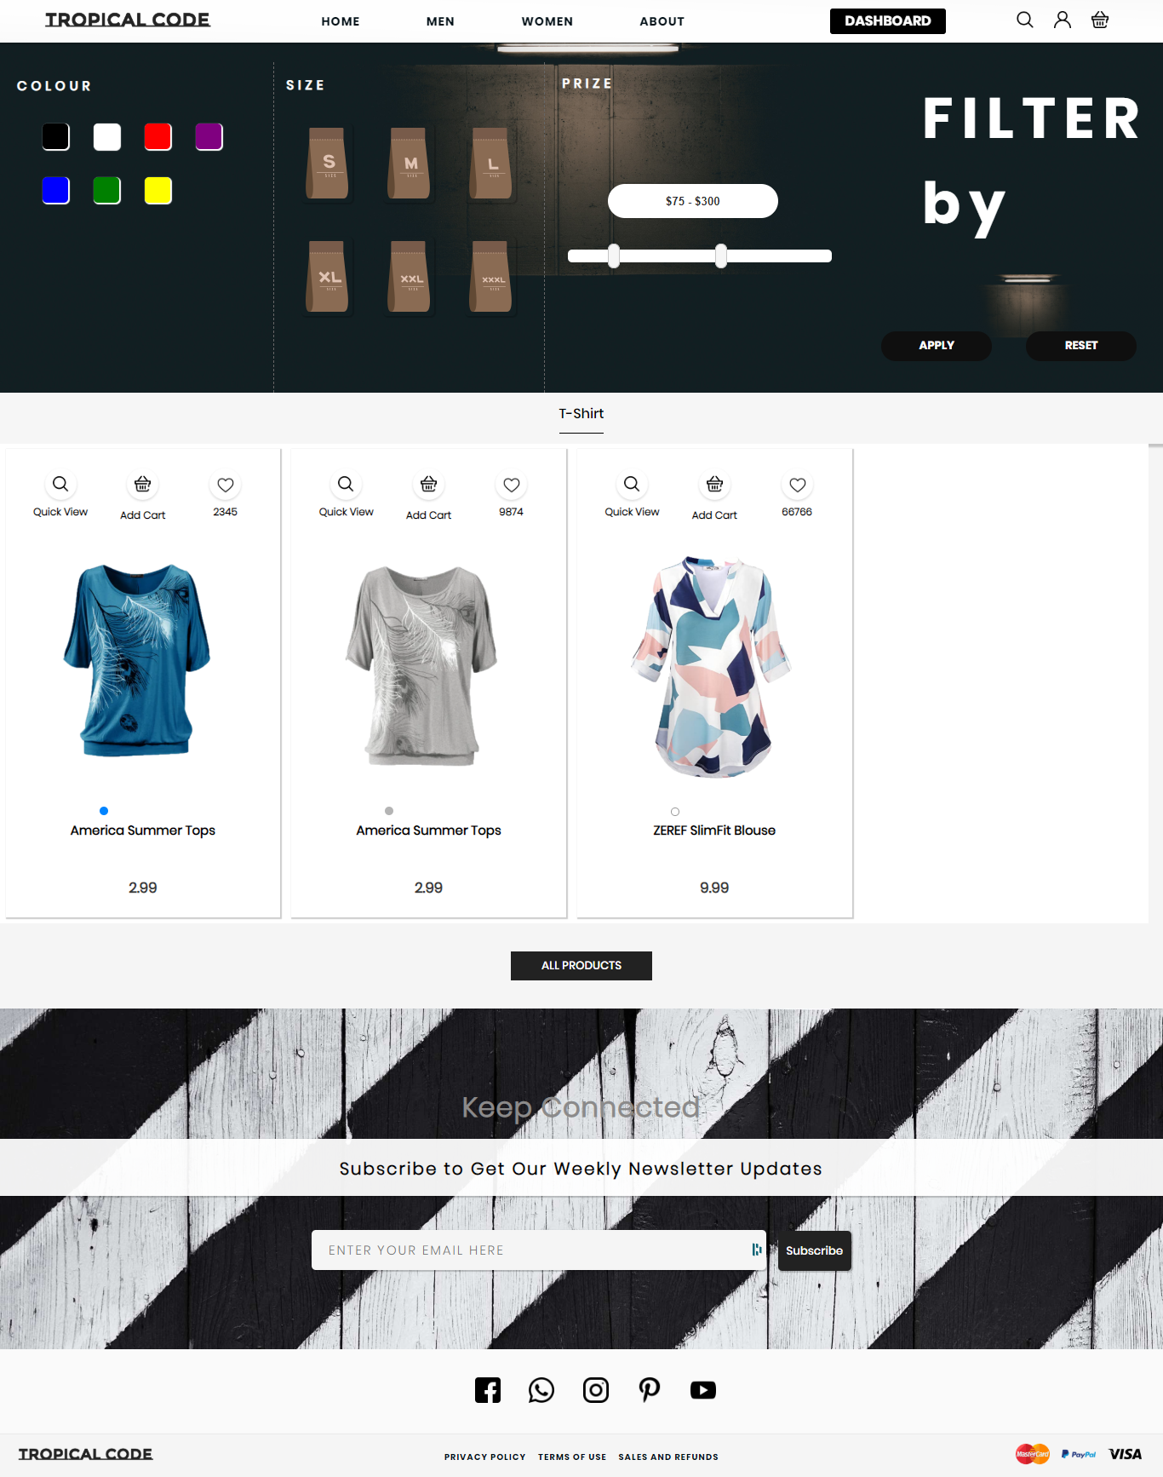

Figure

### Code Snippet

In the folder in the name of “w-t-shirt.png”

#### Jacket

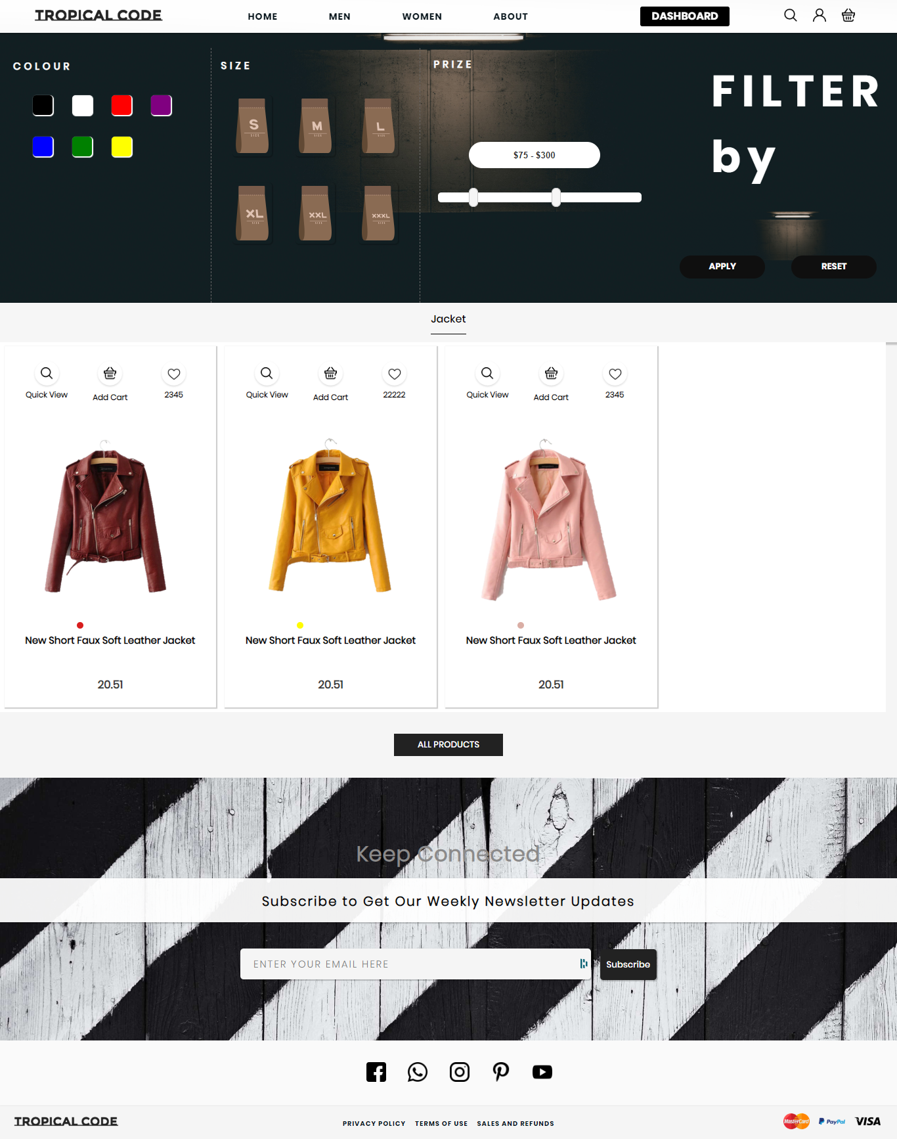

Figure

### Code Snippet

In the folder in the name of “w-jacket.png”

#### Coat

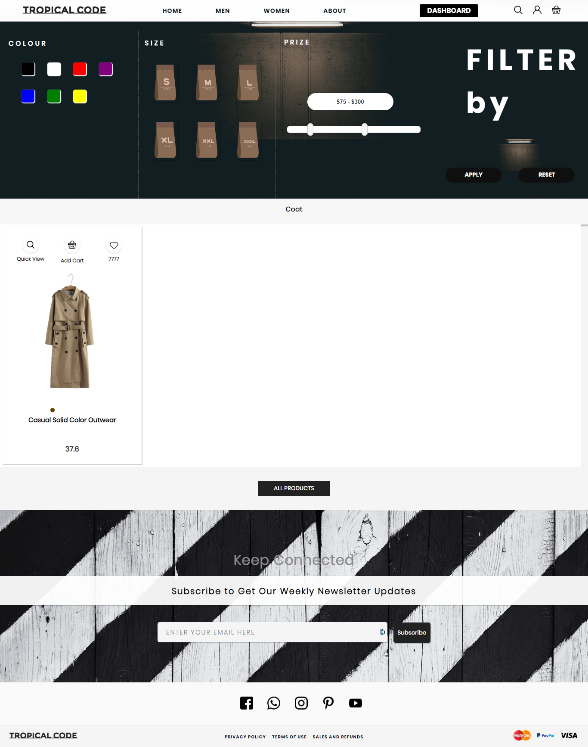

Figure

### Code Snippet

In the folder in the name of “w-coat.png”

### Bottom Page

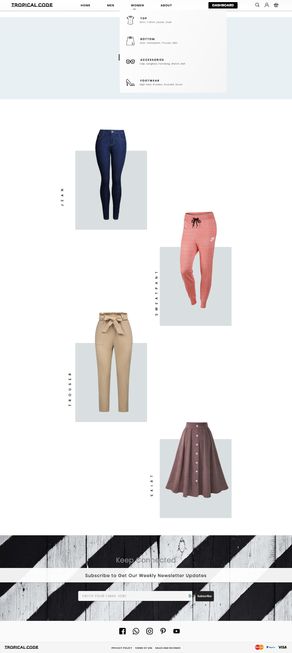

Figure

The bottom page has the categorized option for users to select from.

### Code Snippet

In the folder in the name of “w-bottom.png”

#### Jean

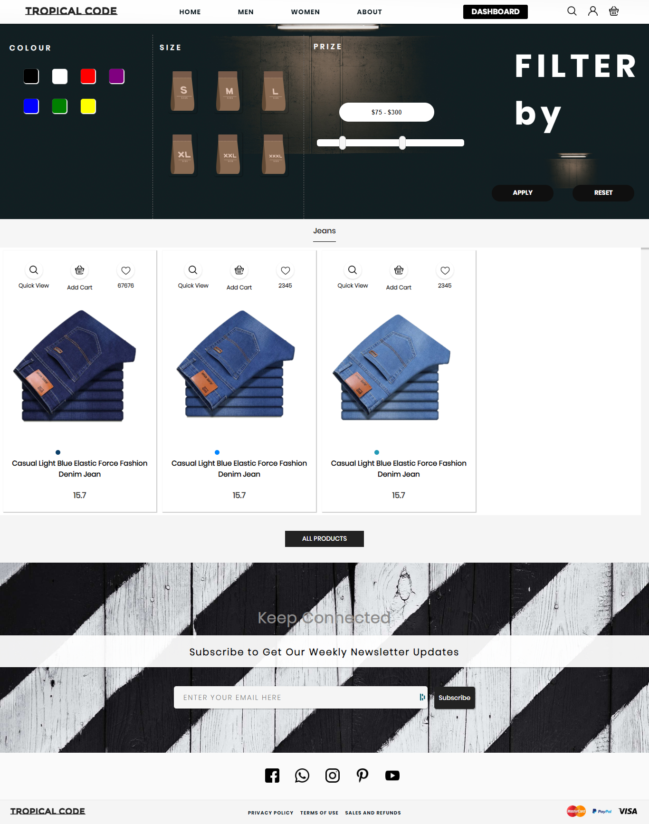

Figure

### Code Snippet

In the folder in the name of “w-jean.png”

#### Sweatpants

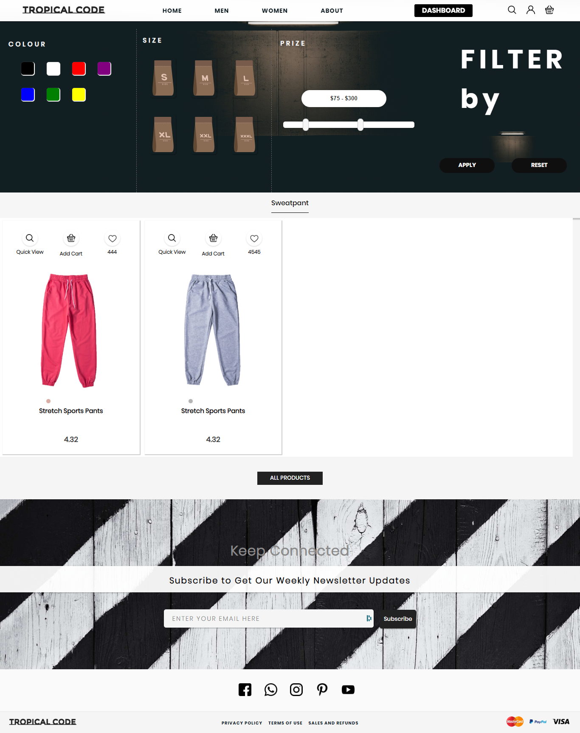

Figure

### Code Snippet

In the folder in the name of “w-sweatpant.png”

#### Trouser

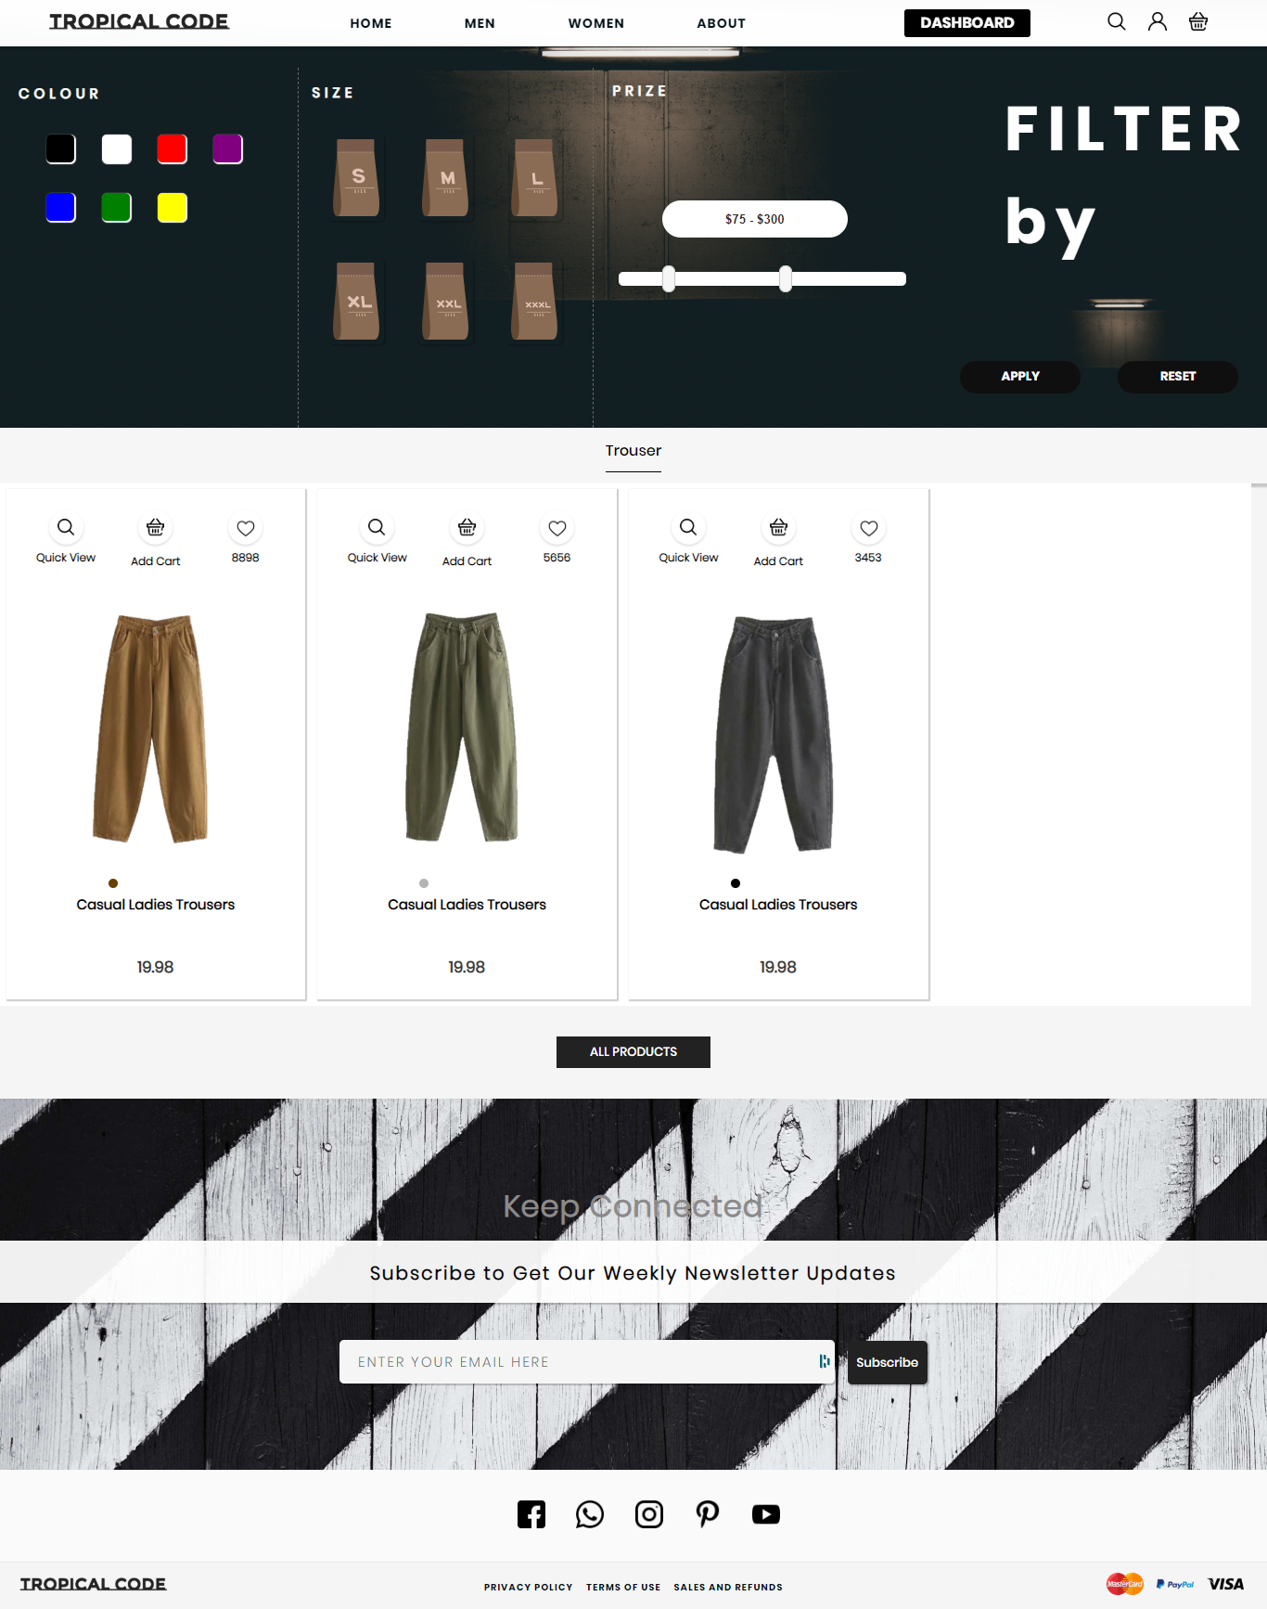

Figure

### Code Snippet

In the folder in the name of “w-trouser.png”

#### Skirt

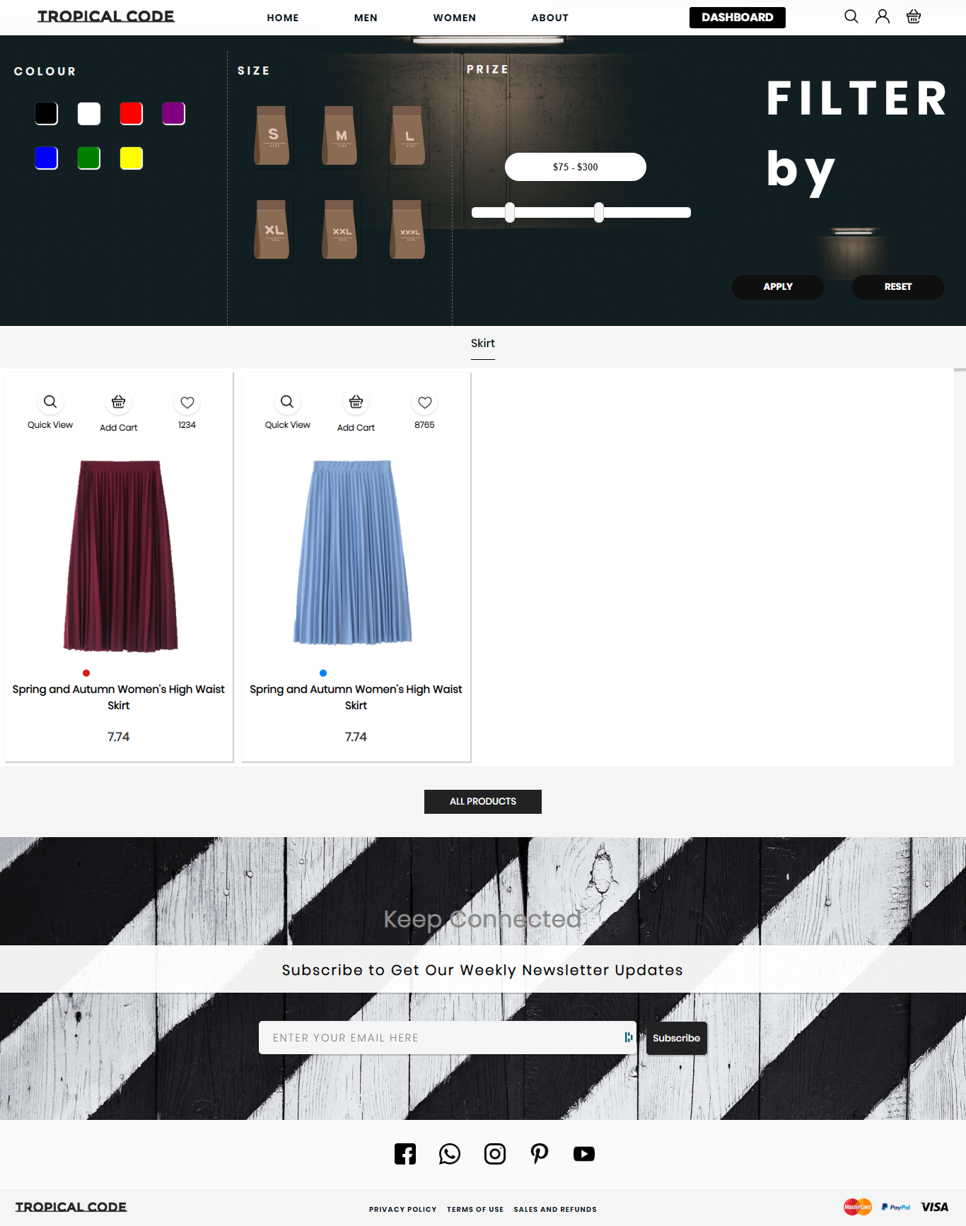

Figure

### Code Snippet

In the folder in the name of “w-skirt.png”

### Accessories Page

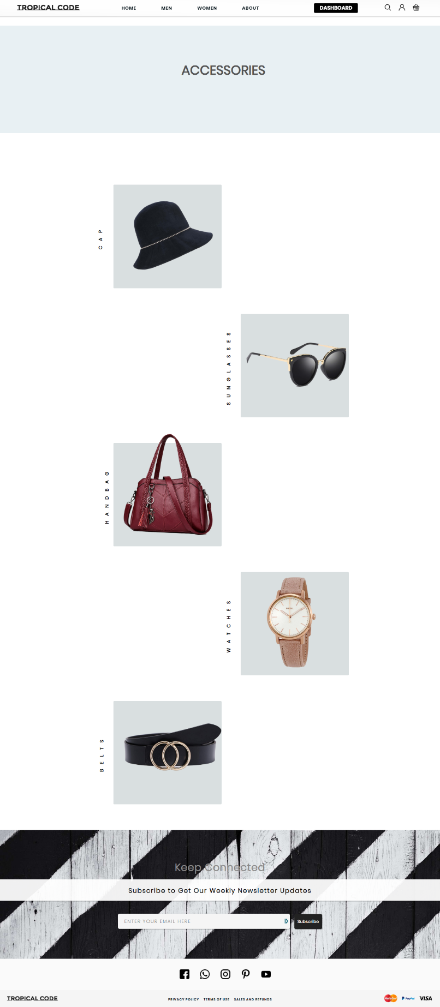

Figure

The accessories page has the categorized option for users to select from.

### Code Snippet

In the folder in the name of “w-accessories.png”

#### Cap

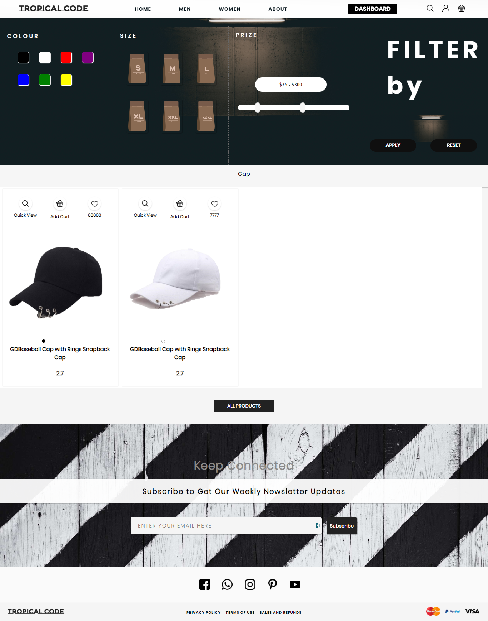

Figure

### Code Snippet

In the folder in the name of “w-cap.png”

#### Sunglass

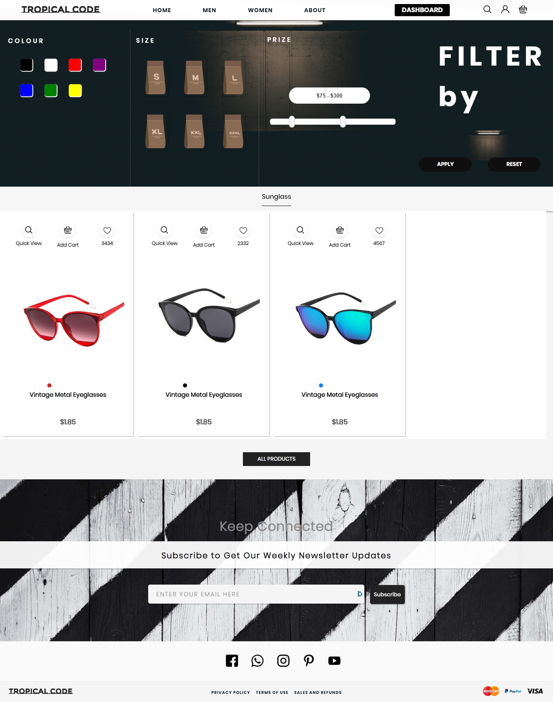

Figure

### Code Snippet

In the folder in the name of “w-sunglass.png”

#### Handbag

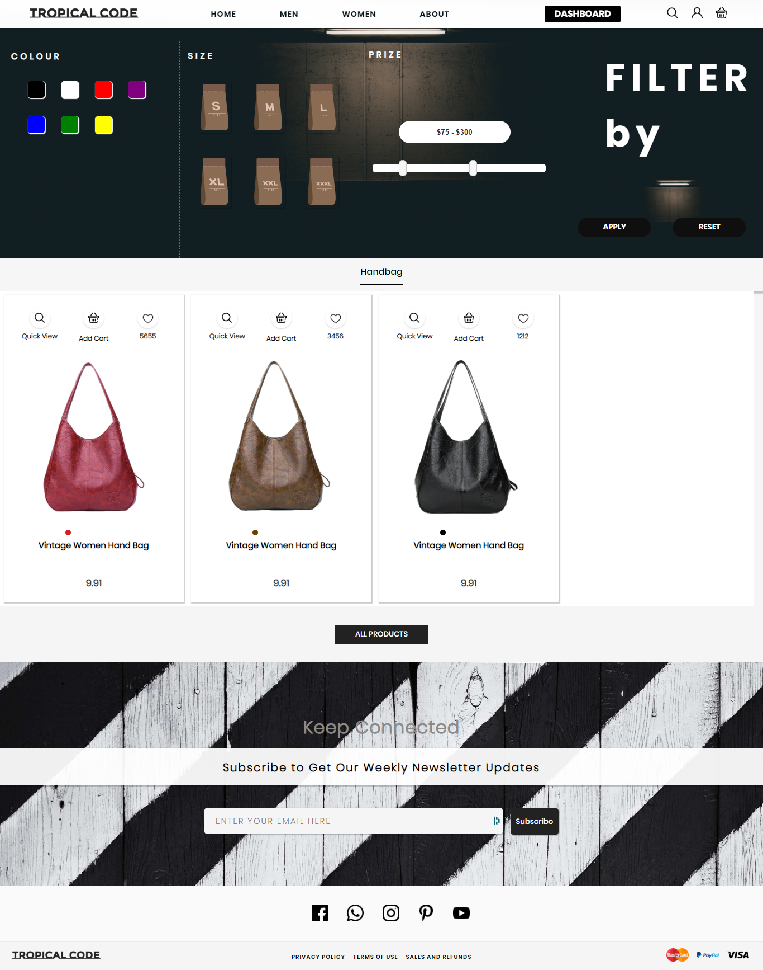

Figure

### Code Snippet

In the folder in the name of “w-handbag.png”

#### Watch

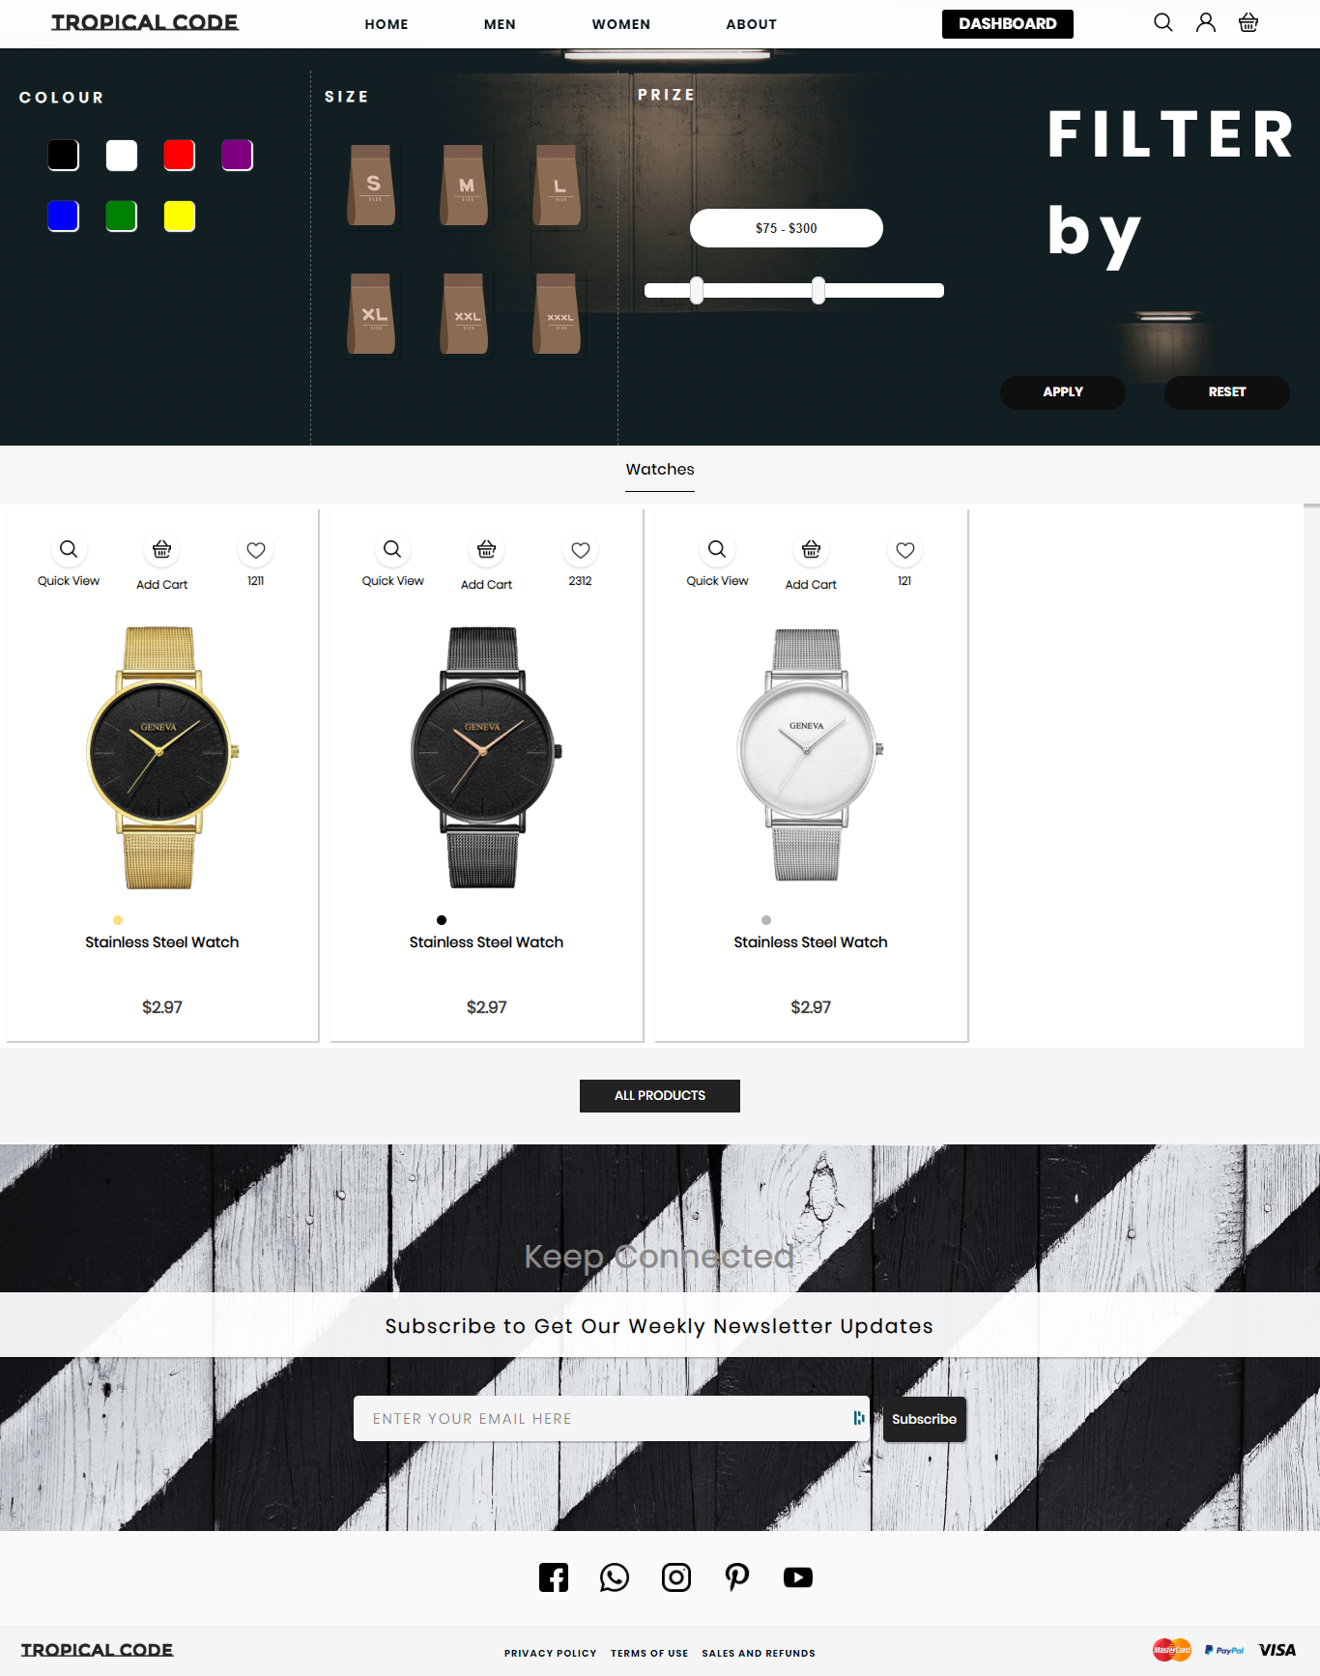

Figure

### Code Snippet

In the folder in the name of “w-watch.png”

#### Belt

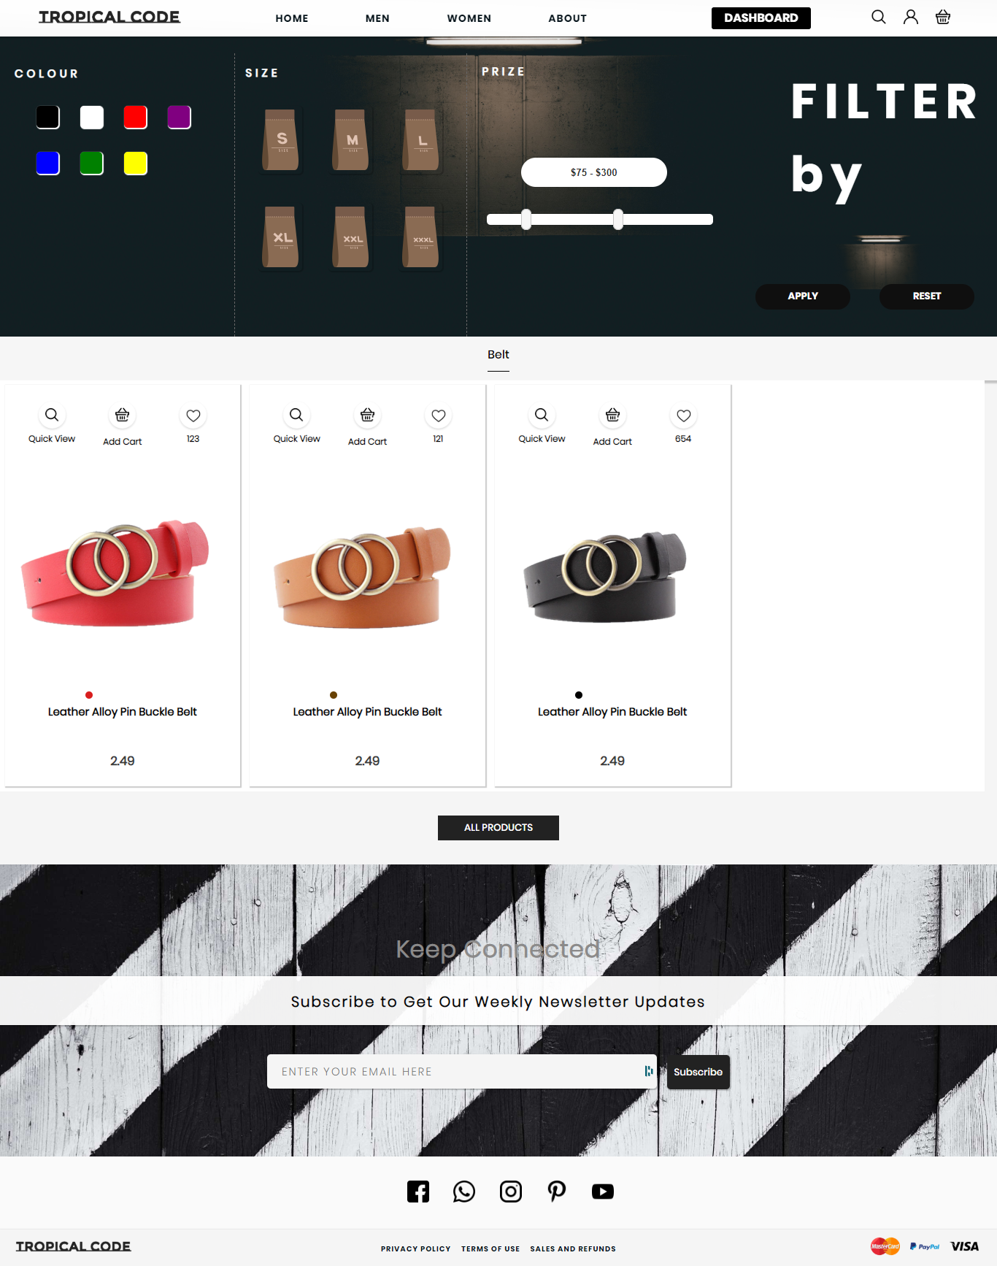

Figure

### Code Snippet

In the folder in the name of “w-belt.png”

### Footwear Page

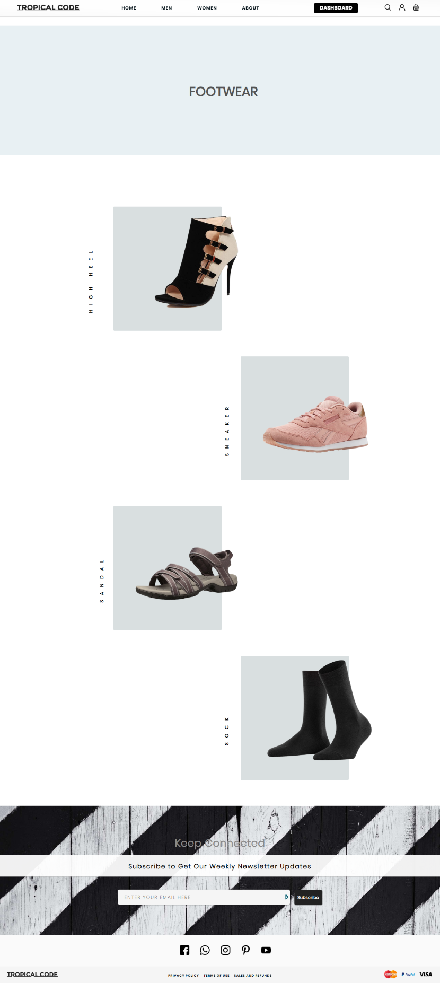

Figure

### Code Snippet

In the folder in the name of “w-footwear.png”

The footwear page has the categorized option for users to select from.

#### High Heel

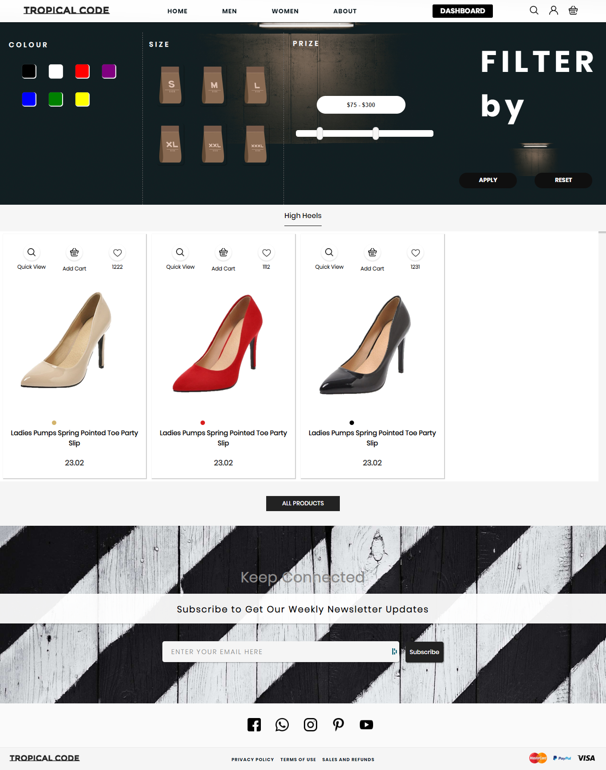

Figure

### Code Snippet

In the folder in the name of “w-high-heel.png”

#### Sneaker

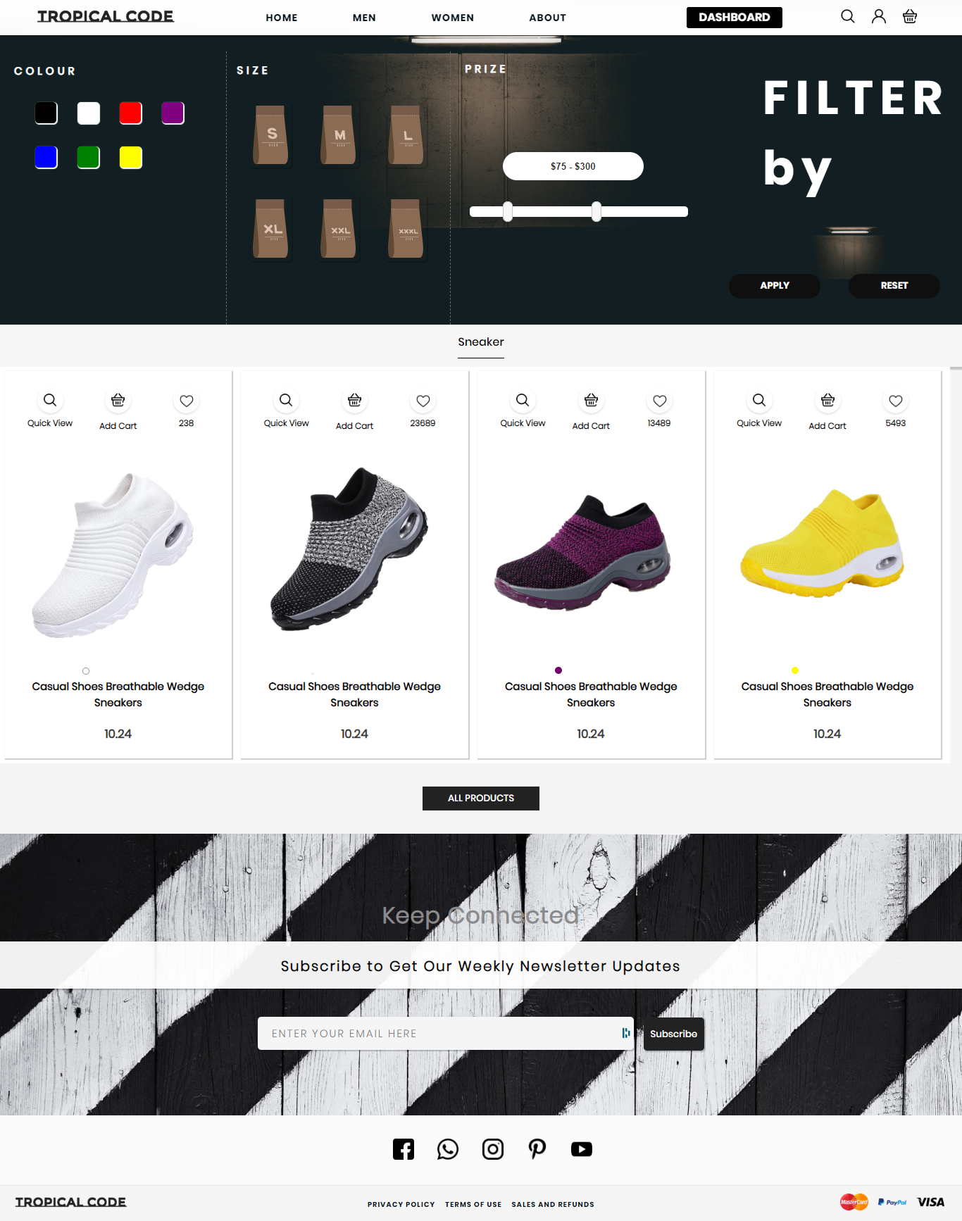

Figure

### Code Snippet

In the folder in the name of “w-sneaker.png”

#### Sandal

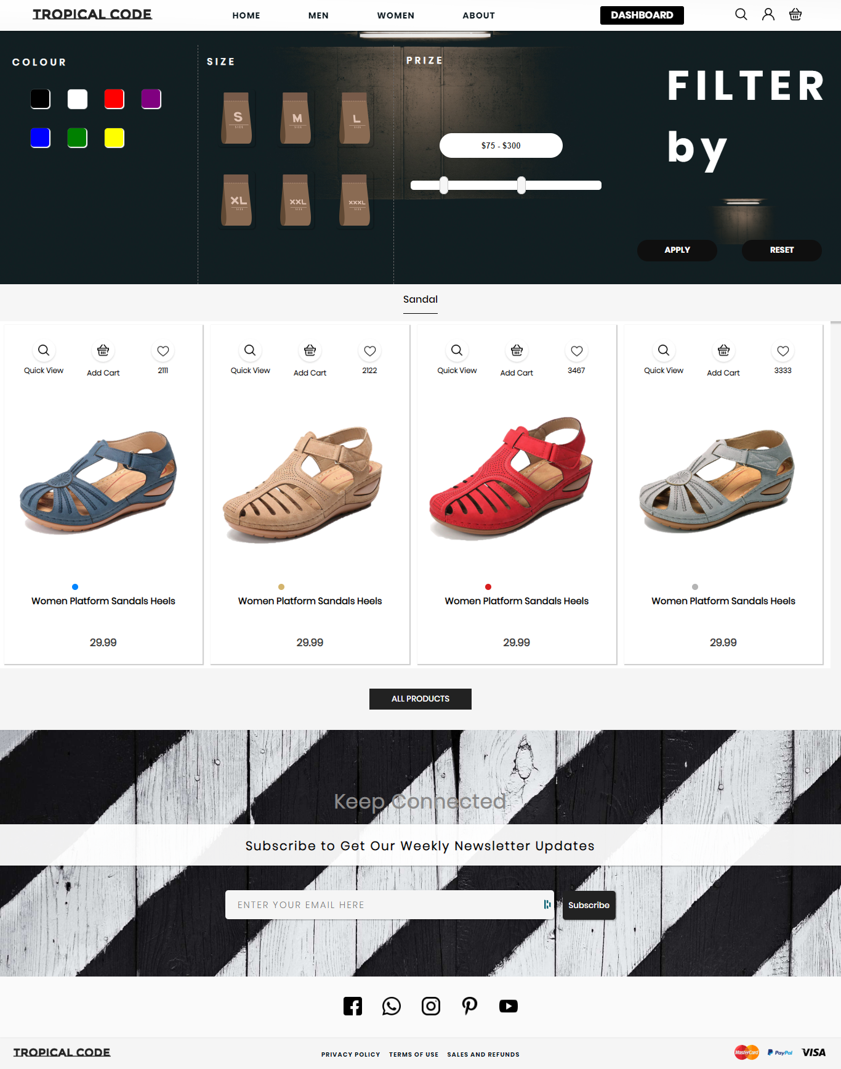

Figure

### Code Snippet

In the folder in the name of “w-sandal.png”

#### Socks

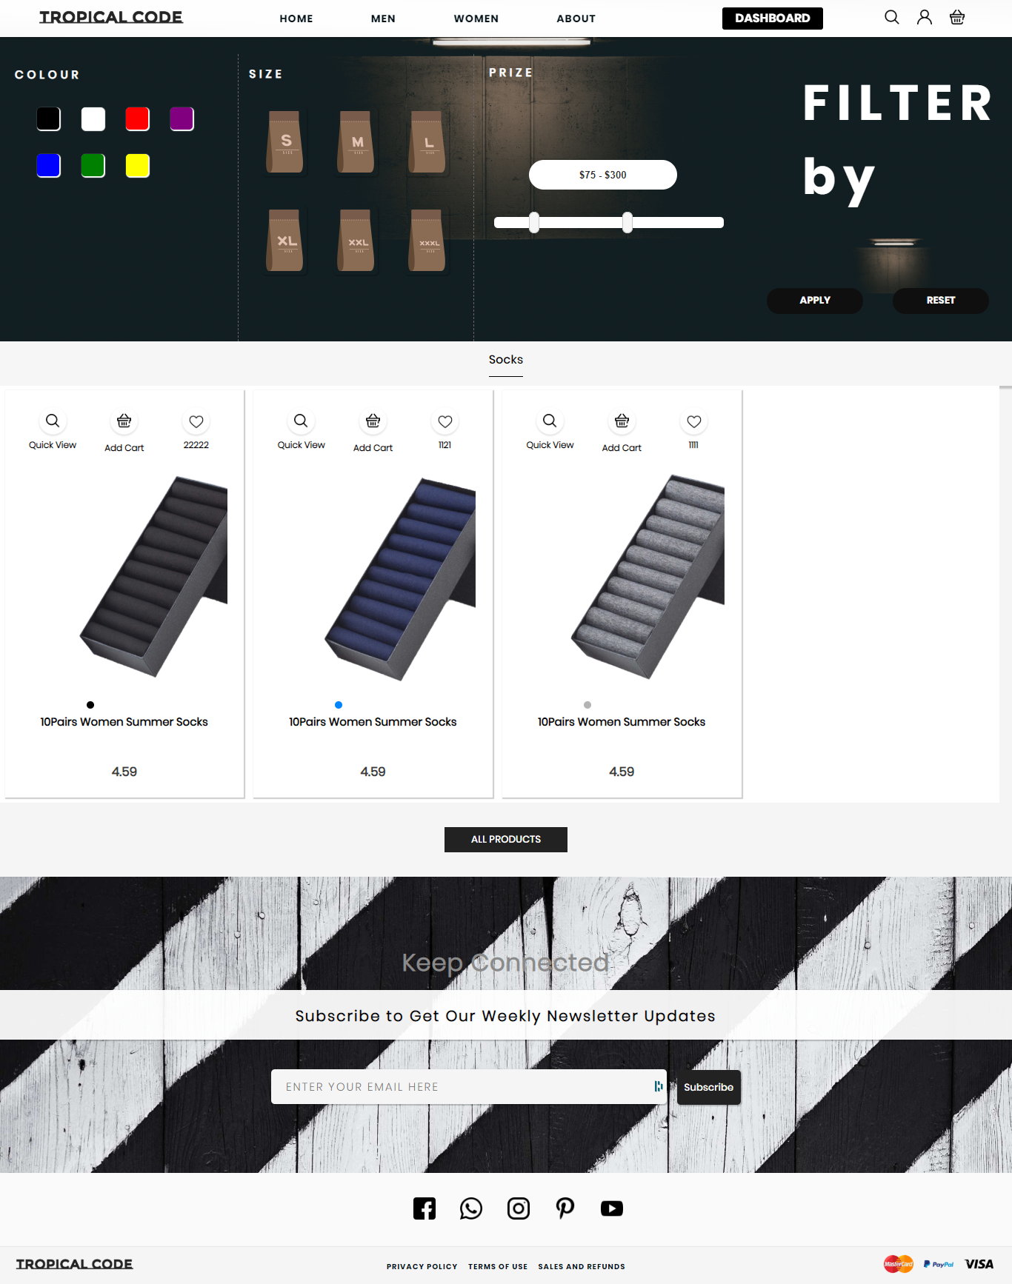

Figure

### Code Snippet

In the folder in the name of “w-sock.png”

### Cart Page

The cart page contain the last view of the products that the user will buy. And wish to pay the bill for those product. The cart page contain the following section:

* Header
* Sidecart
* Profile
* Search
* Cart display
* Footer

#### Cart Display

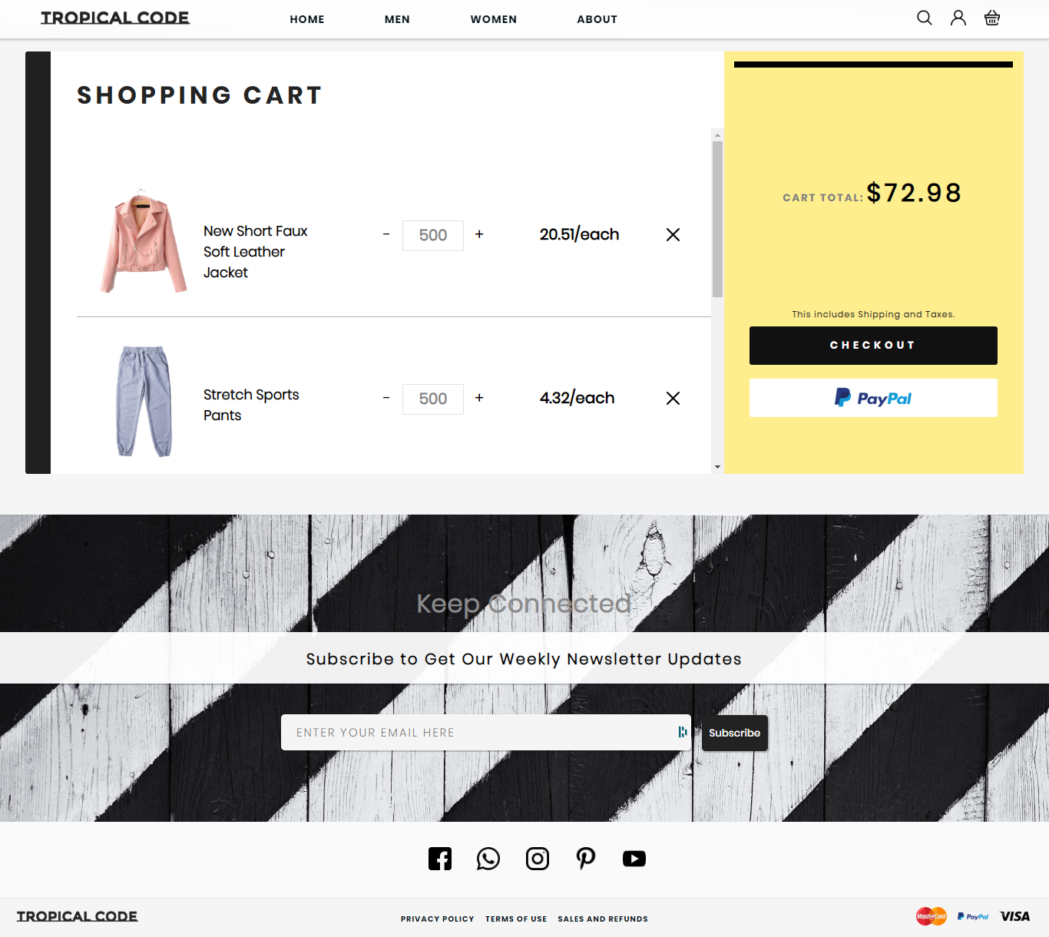

Figure

### Code Snippet

In the folder in the name of “cart.png”

## Future Work

The following section discusses the work that will be implemented with future releases of

the software.

1. Detailed categories: Future work could involve adding more categories which are more

detailed and have additional items.

2. Watch/Wish List: Work can add a watch list or wish list so that users can add an item to a

list to watch for item prices to go down or to see when there is a sale on any of those items.

68

3. Enhanced User Interface: Work on enhancing the user interface by adding more userinteractive features.

4. Recommended Items: Add a bar that would display the most-recommended items which

would depend on the number of times an item has been purchased by any users.

5. Payment Options: Add different payment options, such as Visa, MasterCard, PayPal, etc.,

where a user can also save the card information for later checkouts.

6. Shipping Options: Add different types of shipping options: regular shipping, expedited

shipping, international shipping, etc.

7. Recent History: Display the user’s recently browsed items in the recent-history tab.